# ABC Product Delivery - Functional Test Document

# Overview

ABC is a B2B organization that provides offers delivery services and facilitates business expansion.

ABC objective is to automate essential procedures through the development of a Pega application. The application should be simple to use and easily expandable to enable future upgrades, as stated in below list of processes.

The need is to build a delivery solution, competent of automating the tasks efficiently:

1. Business partner Registration and Renewal
2. Shipment Request
3. Shipment Delivery Request / Demand
4. Truck Assignment
5. Vendor Registration

# Implementation Discussion

Implementation discussions about the identified tasks are as follows:

## Business Partner Registration/Renewal Case

Business partner registration process is having its own life cycle.

The Business Partner initiates the registration process using the Pega Mashup and anonymous authentication is used to launch mashup case creation. The business partner presents the case for approval to Executive Manager after payment by providing necessary registration information such as business partner information, membership plan, and payment.

**[Caveat: DUE TO TIME CONSTRAINT USER4 ARE ASSIGNED FOR THE MODEL USER TO AUTHENTICATE USER FROM MASHUP**

**RENEWAL PROCESS SETUP AS NEW CASE TYPE AND IMPLEMENTATION IS SKIPPED BUT IDEA IS TO REUSE STEPS DEFINED IN REGISTRATION AS MUCH AS POSSIBLE]**

**Case Lifecycle diagram:**

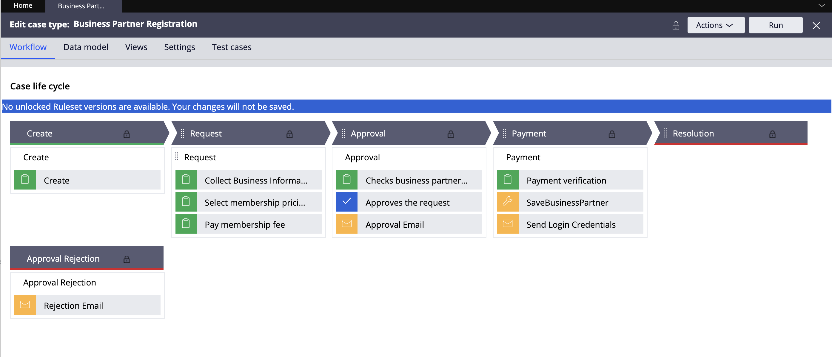

Once user launches the business partner creation mash up case creation begins and the case data is business partner information is filled in, initially:

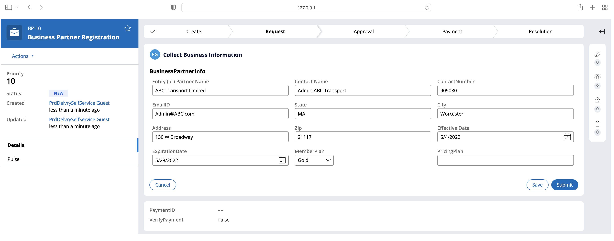

On Submission, this goes for Registration stage to choose pricing plan:

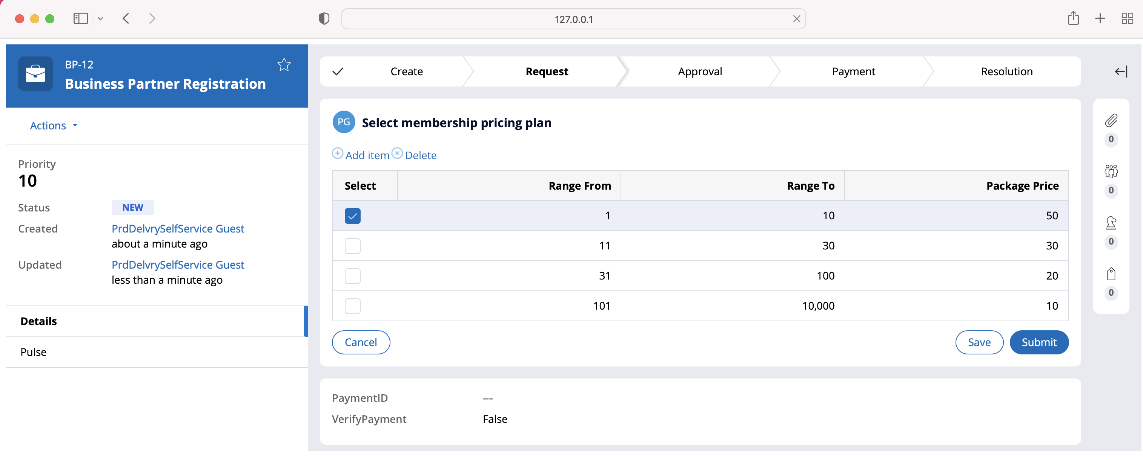

Upon selecting the pricing plan and submission user is taken to confirm the payment details

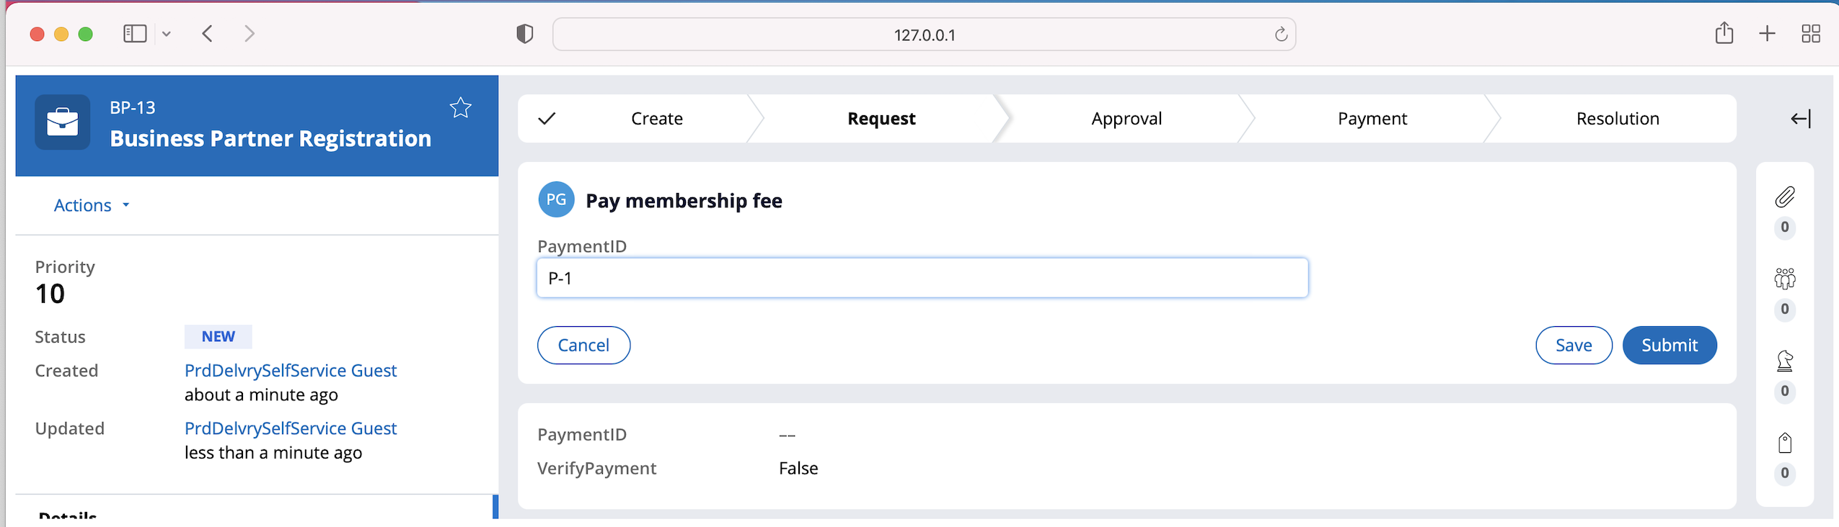

**[Caveat: DUE TO TIME CONSTRAINT FREE FORM TEXT TO FILL THE PAYMENT ID ]**

Upon entering the payment information case goes to execute manager approval

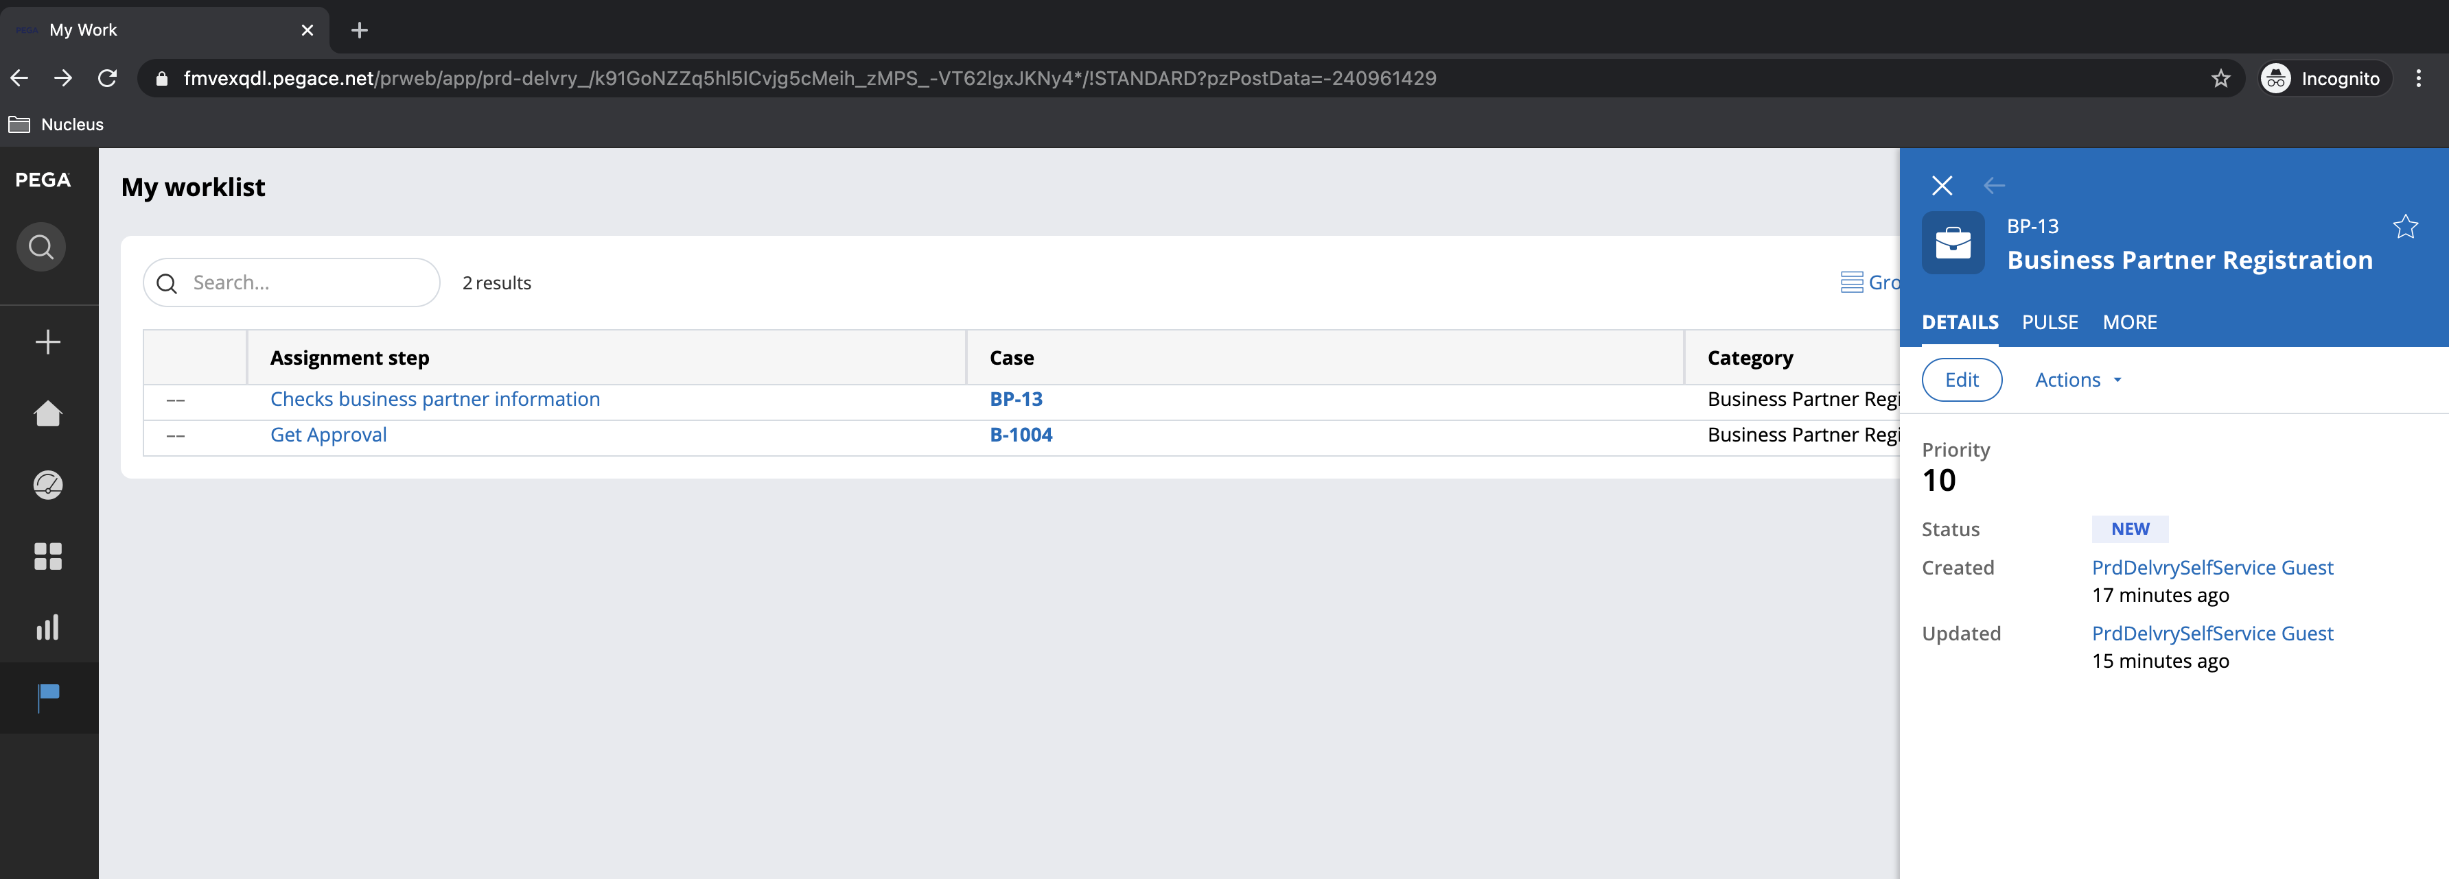

When logged in, the executive manager can see the case data. For that user required will be

User ID : ExecutiveManager@Prd.com

Password: rules



Once executive manager clicks on case

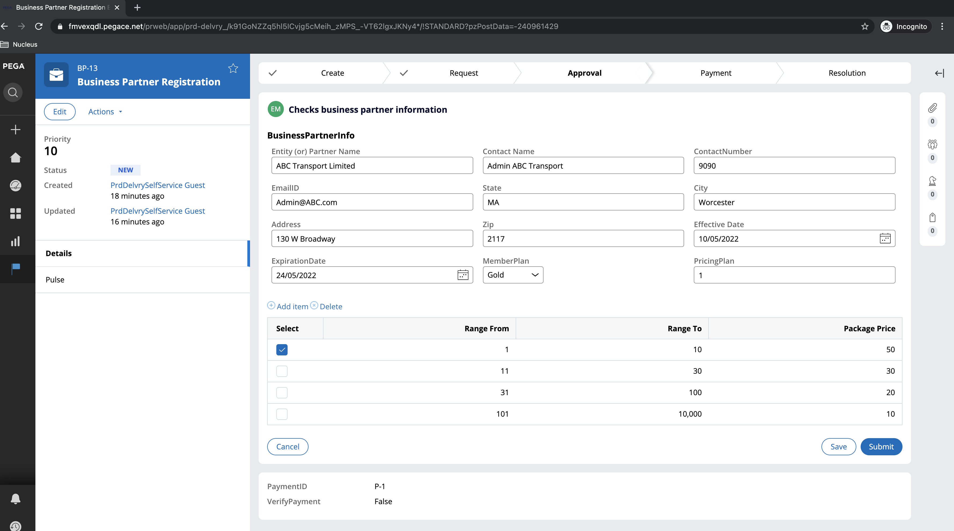

Once executive manager reviews and considering the happy path executive manager approves the request. In other scenario if case is rejected it goes to alternate stage Approval Rejection and email is sent to partner email id

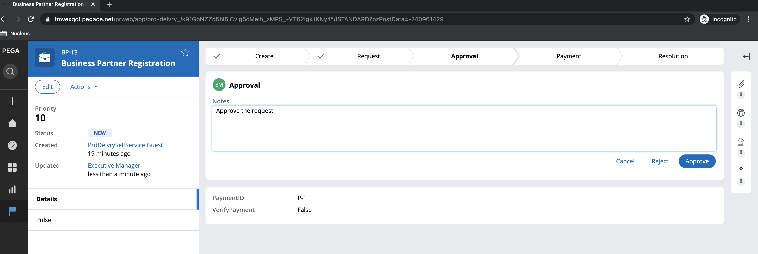

Once case is approved a new record is inserted into business partner data type **ABC-Data-BusinessPartners**

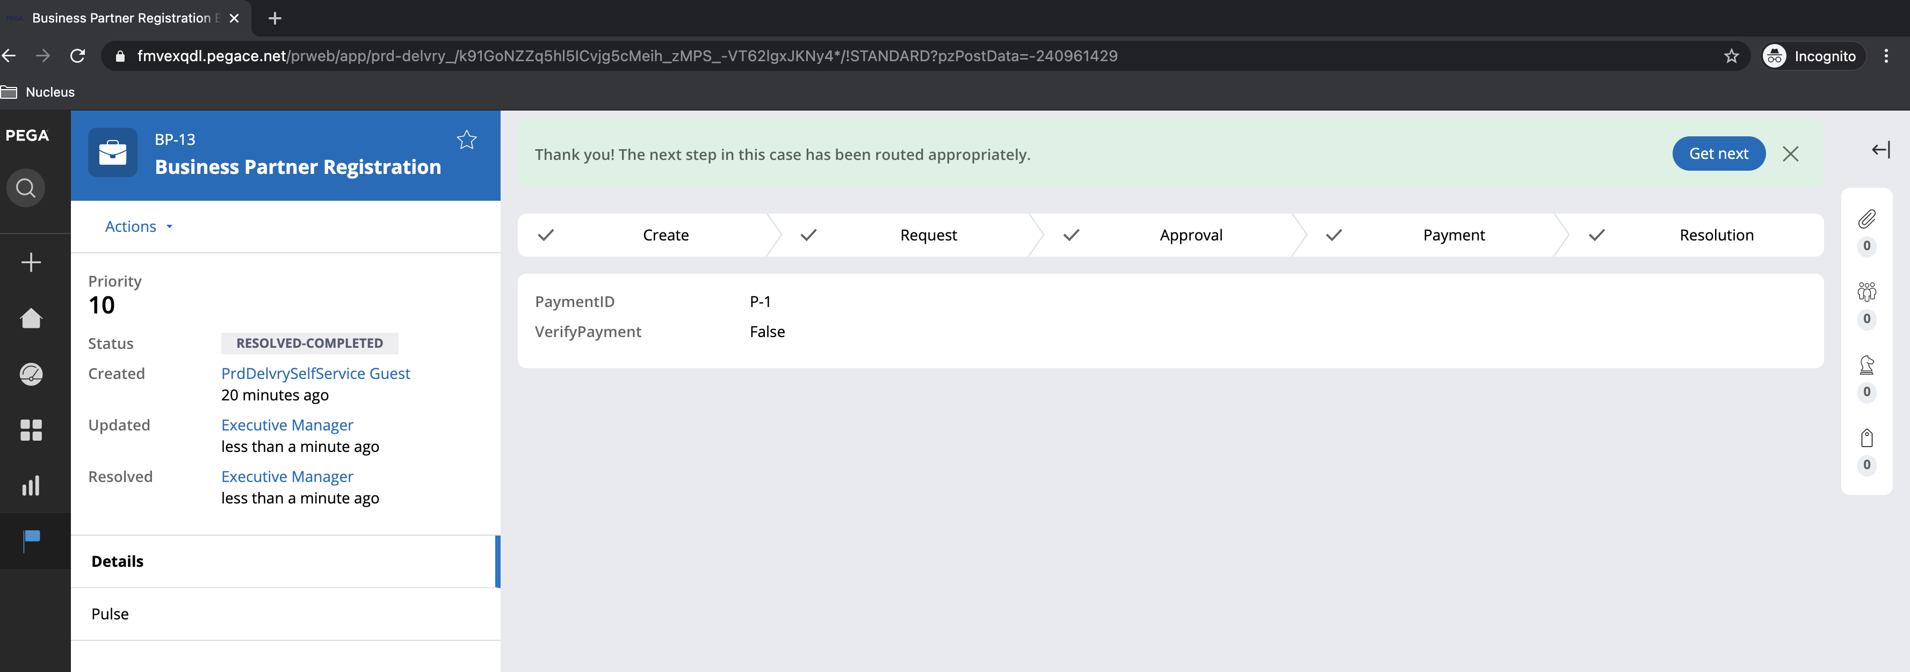

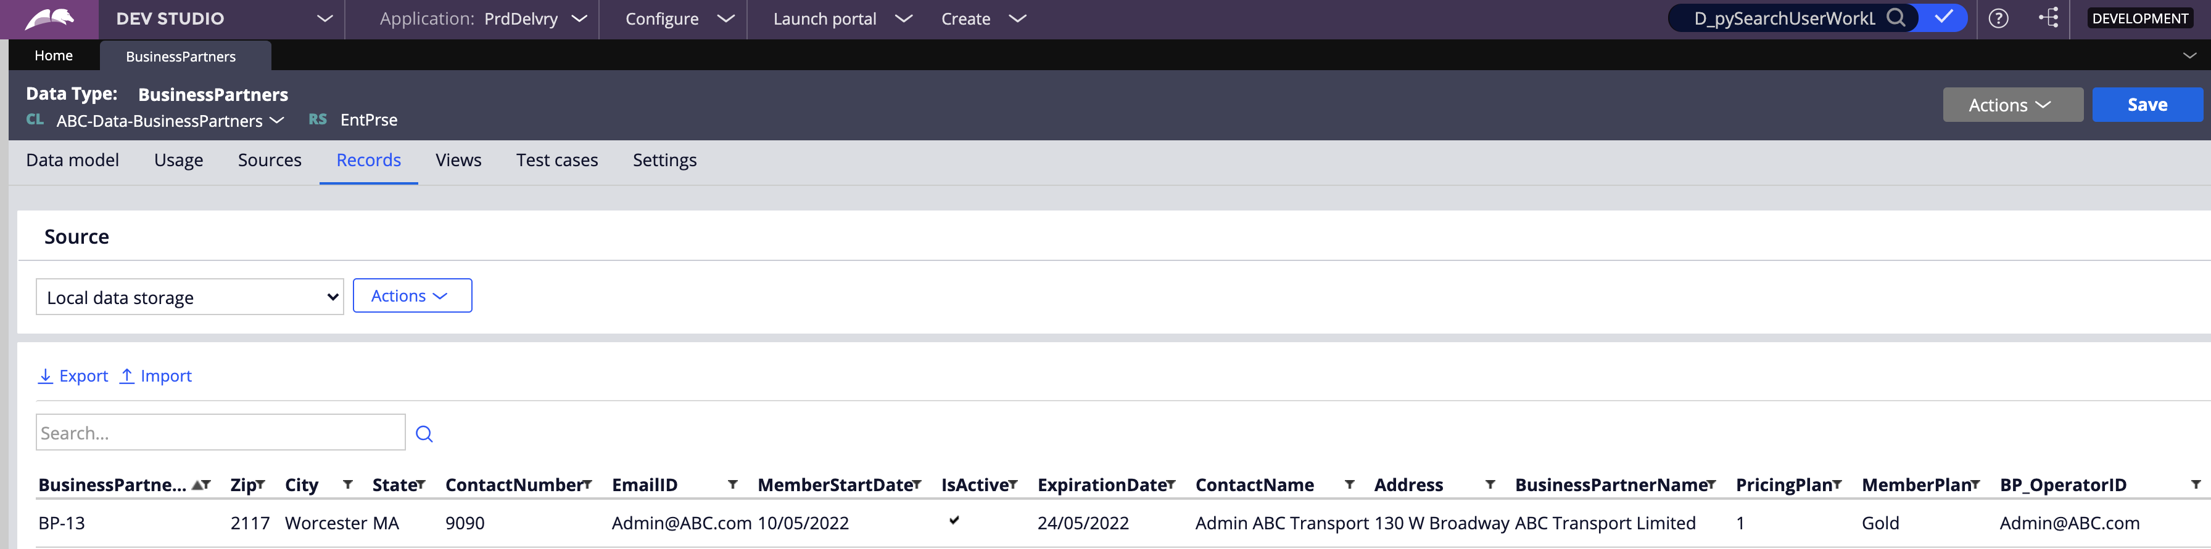

Emails gets both in approval and to send login credentials

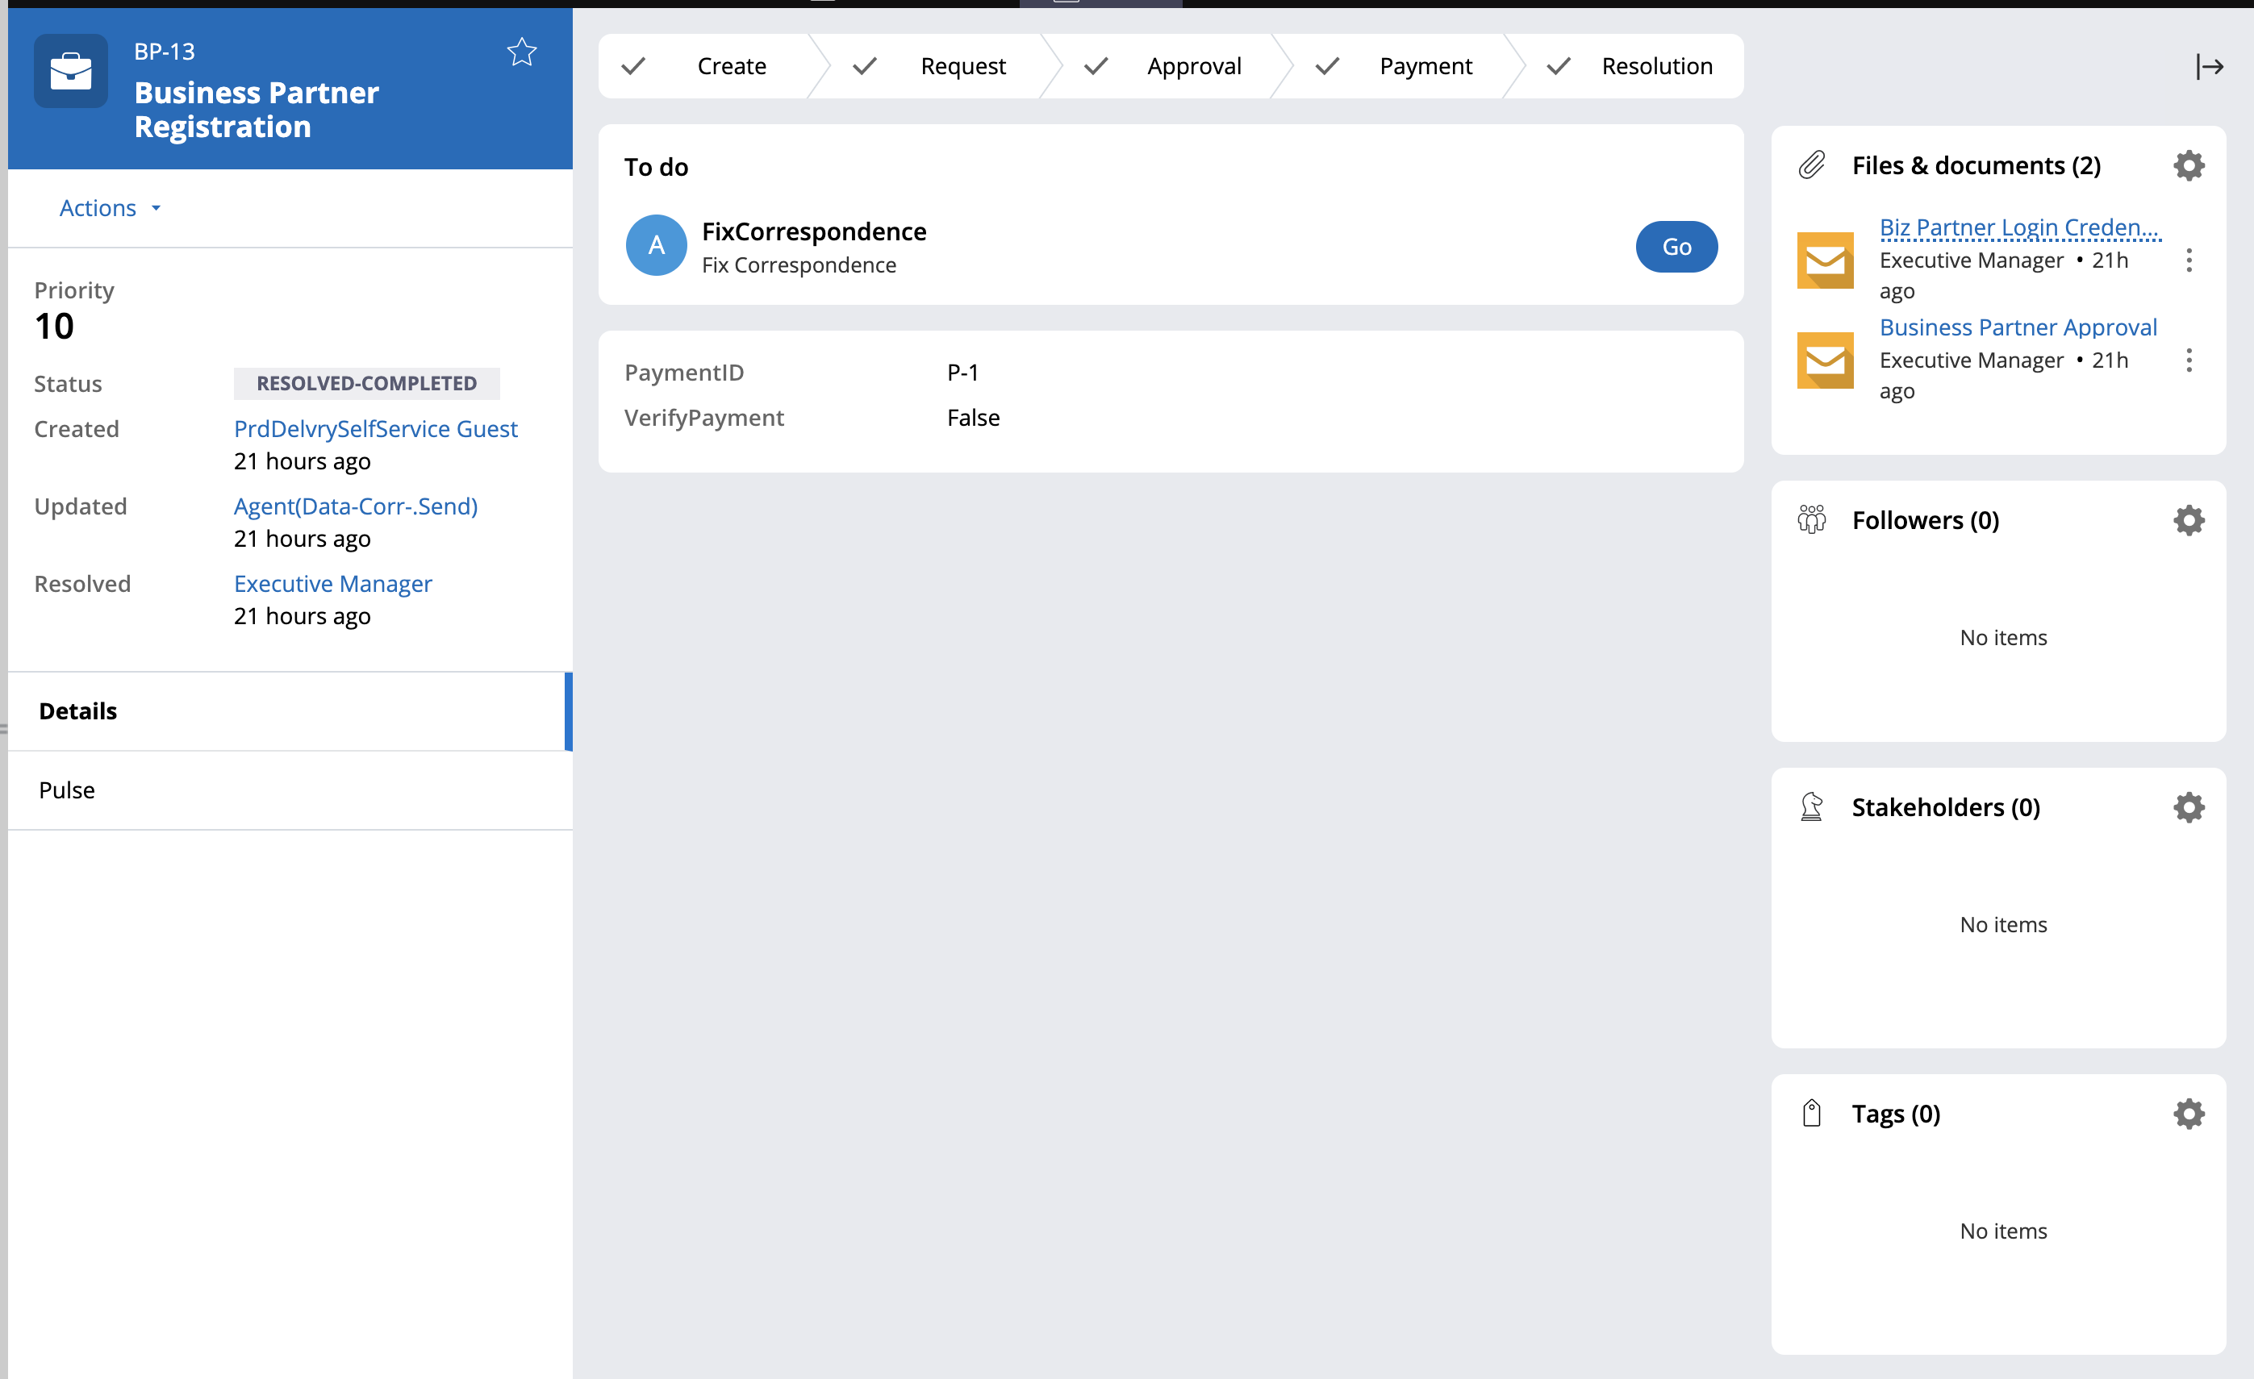

**[Caveat: DUE TO TIME CONSTRAINT CREATION OF OPERATOR ID SKIPPED BUT IDEA IS TO USE SIMILAR PROCESS WHEN APPLICATION WIZARD REQUEST TO ADD NEW OPERATOR ID]**

## Shipping Request Case

Once business partner initiate a shipping request, the user inputs the required information and the package's price is determined based on the partner plan. This case will wait in a work basket until Job Schedulers creates the Shipment Delivery case as per the scheduled time 1:00 PM, once, Shipment delivery case is completed the status will be updated back to shipment request case upon the completion.

**Case Life Cycle Diagram:**

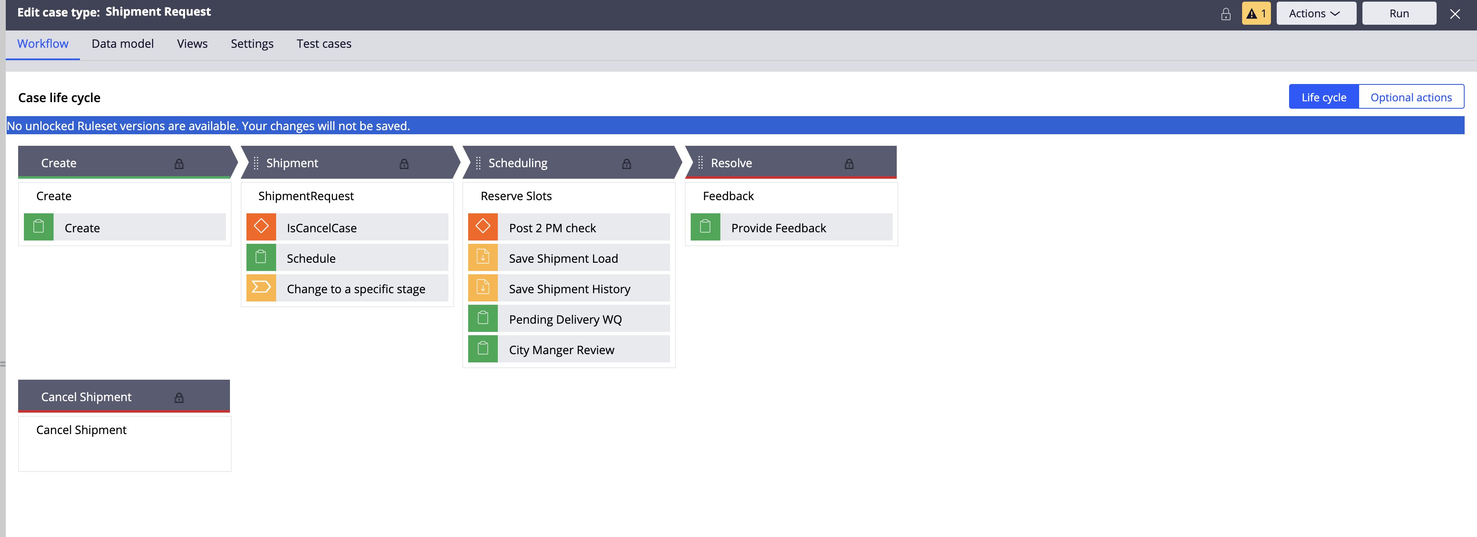

*Case Creation Steps:*

**[Caveat:** [**Admin@ABC.com**](mailto:Admin@ABC.com) **mapped as business partner operator ID )]**

Operator ID : [Admin@ABC.com](mailto:Admin@ABC.com)

Password: rules

Business Partner Logs in the Application and clicks on create Shipment Request Creation:

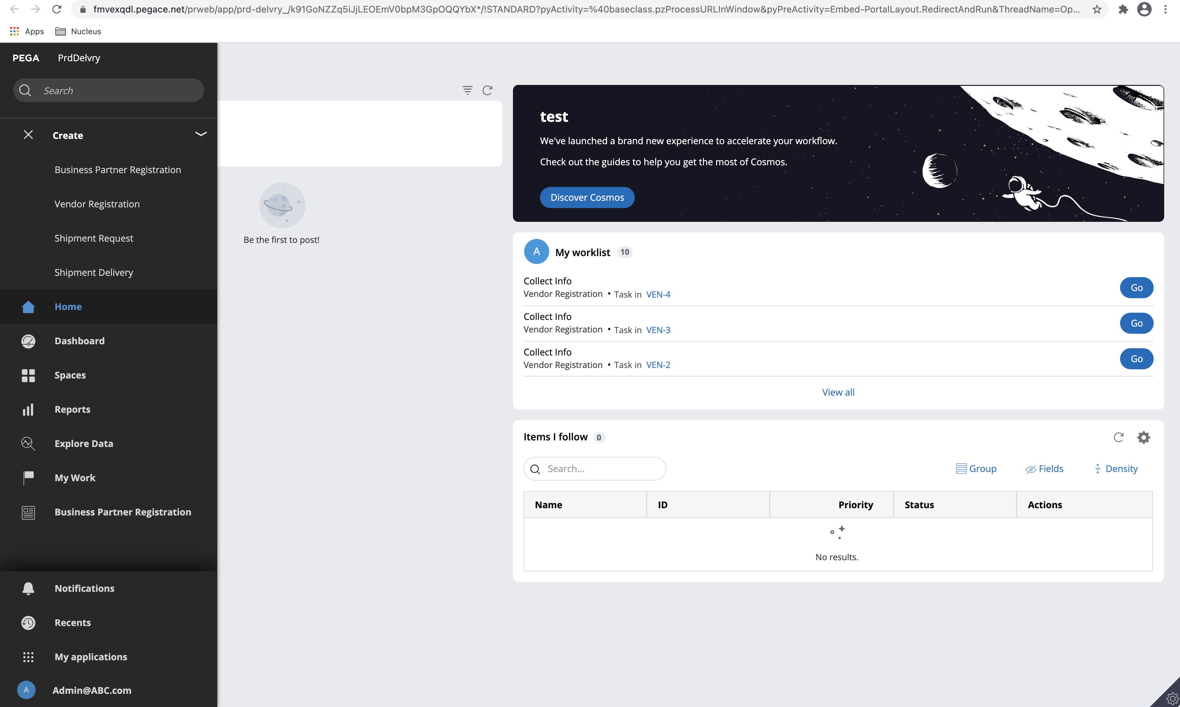

Case is filled with by default business partner information

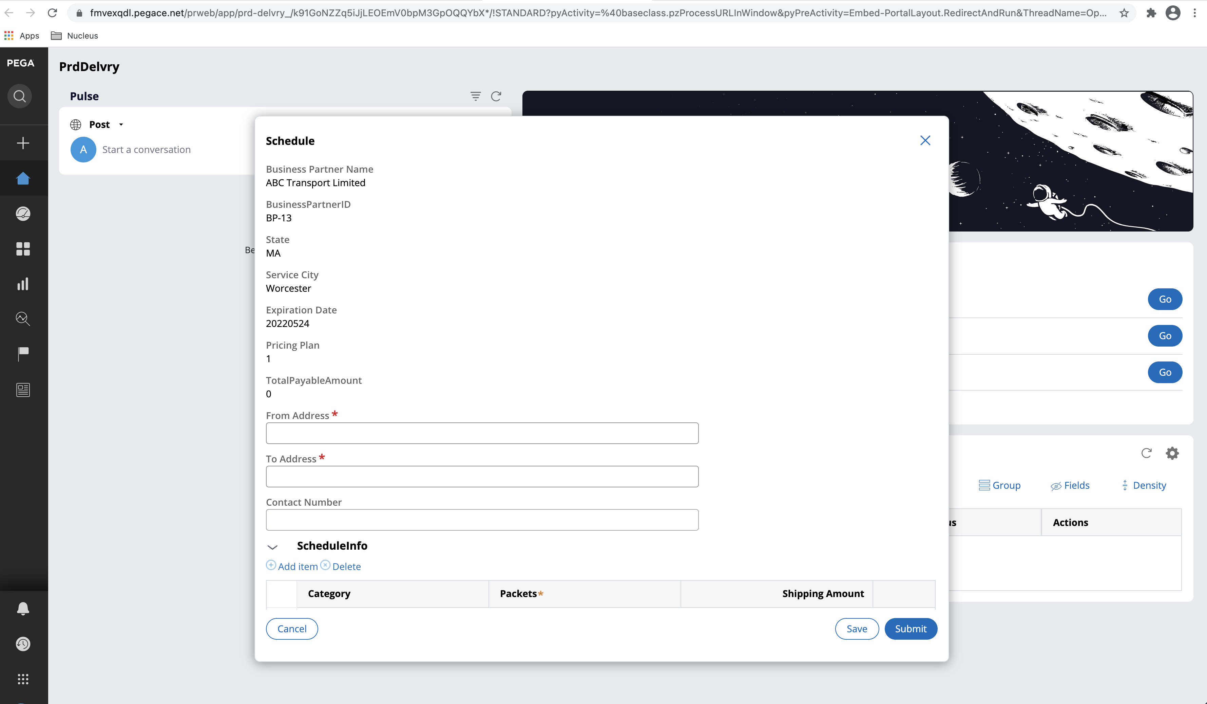

The From and To Address are filled in and Shipment category is selected:

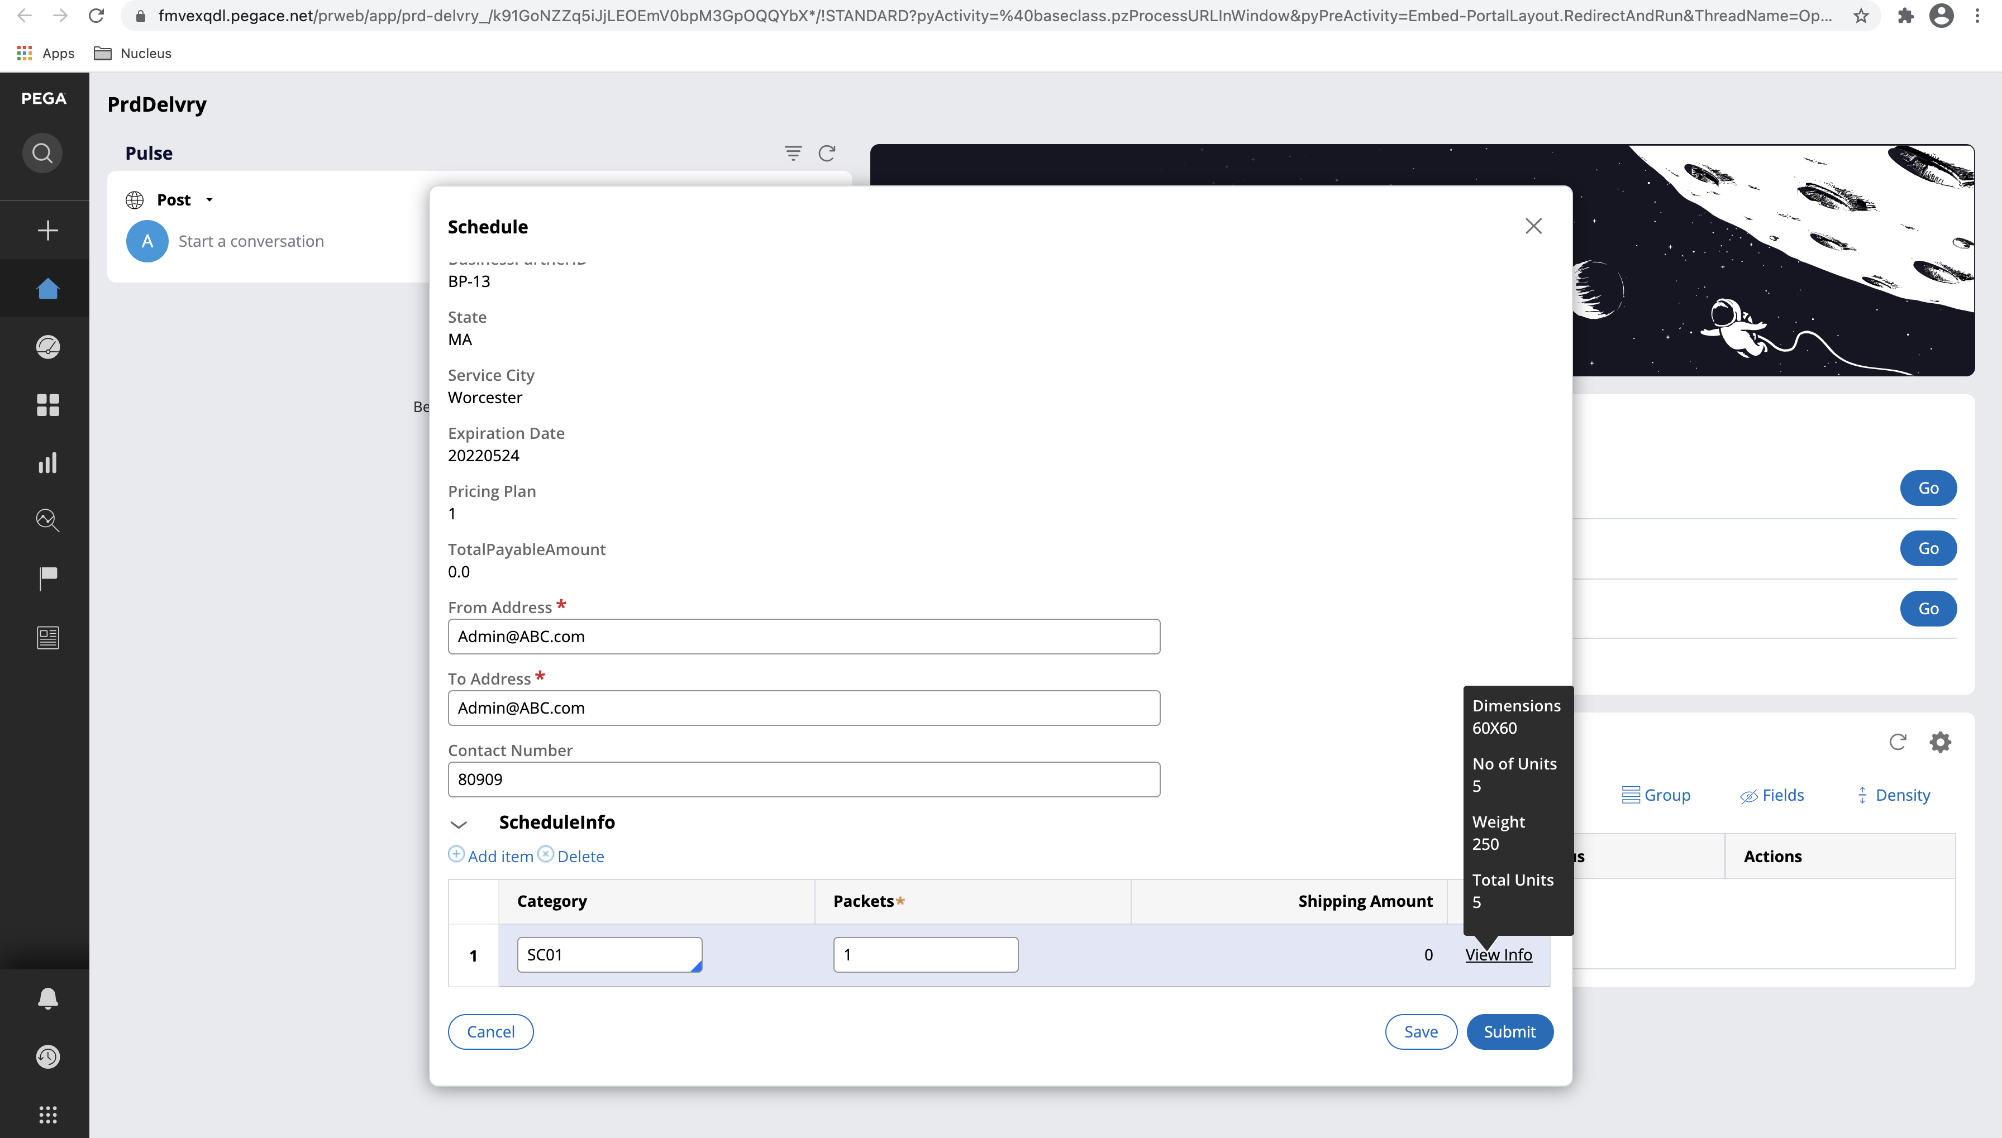

[Caveat: FOR POC PERSPECTIVE, THE INPUT DATA HAS BEEN SIMULATED. IN ACTUAL WHENEVER THE BUSINESS PARTNER CREATES THE SHIPPING REQUEST CASE , ALL THE DATA STORED FOR THAT OPERATOR IS FETCHED FROM ID:ABC-Data-BusinessPartners]

On Submission, the Case will be routed to City Manager Approval:

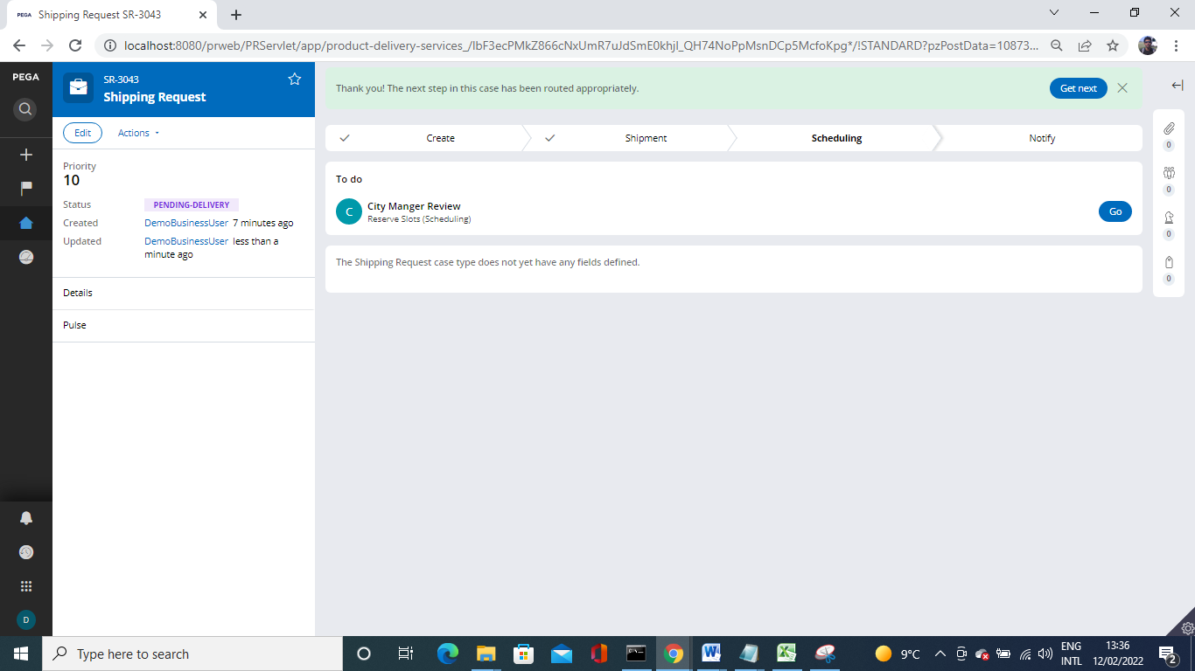

City manager (Worceste@CityManager) is used to route the shipment request.

Login : Worceste@CityManager

Password: rules

In dashboard home page SR-4 ( shipment request ) is shown

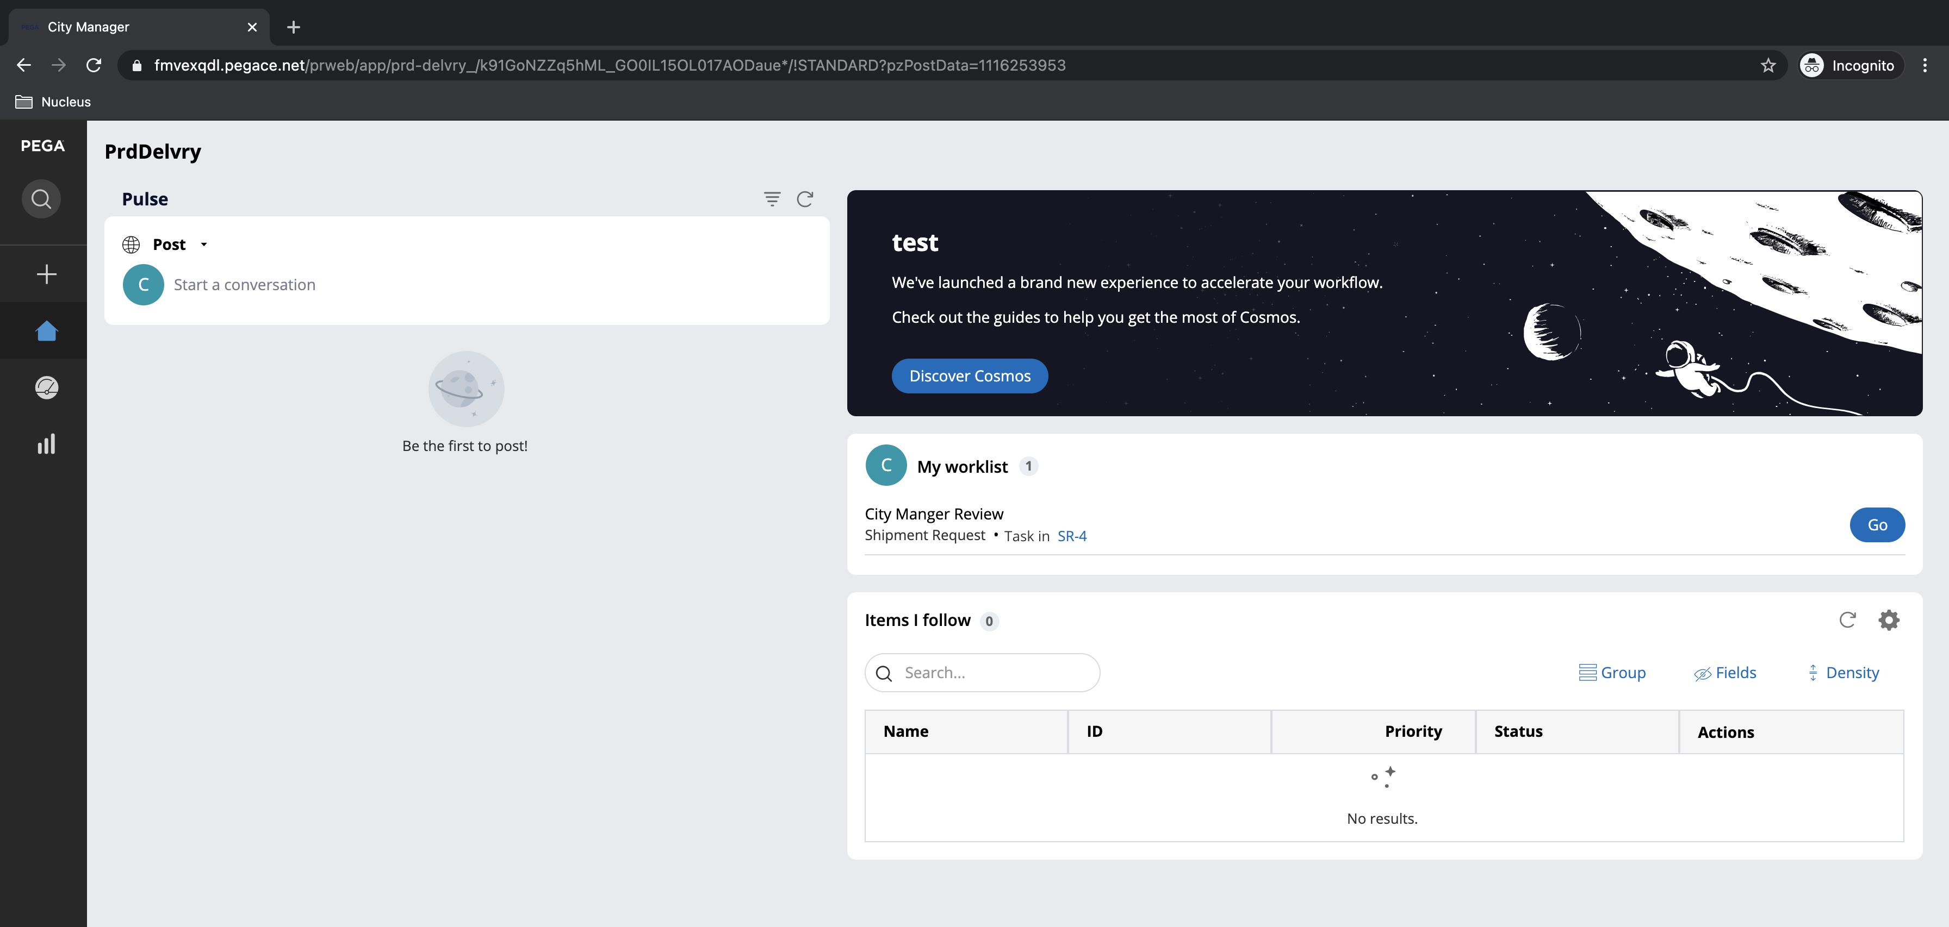

Upon clicking the Go, case opens

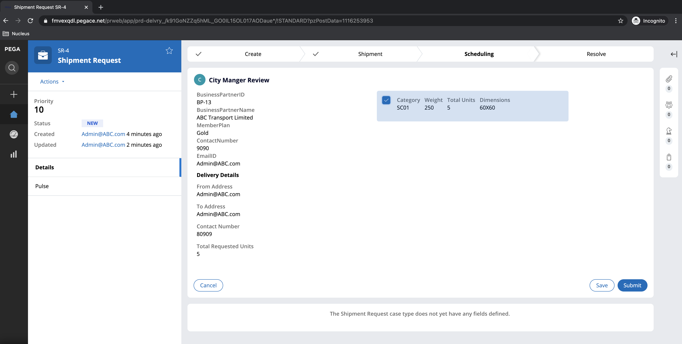

The case then goes to Pending Delivery Work Queue. This case will wait in a work basket until Job Schedulers creates the Shipment Delivery case as per the scheduled time 1:00 PM, once, Shipment delivery case is completed the status will be updated back to shipment request case upon the completion.

[Caveat: CASE MOVED MANUALLY OUT OF DELIVERY WORK QUEUE]

Pick up from delivery work queue and submit the case

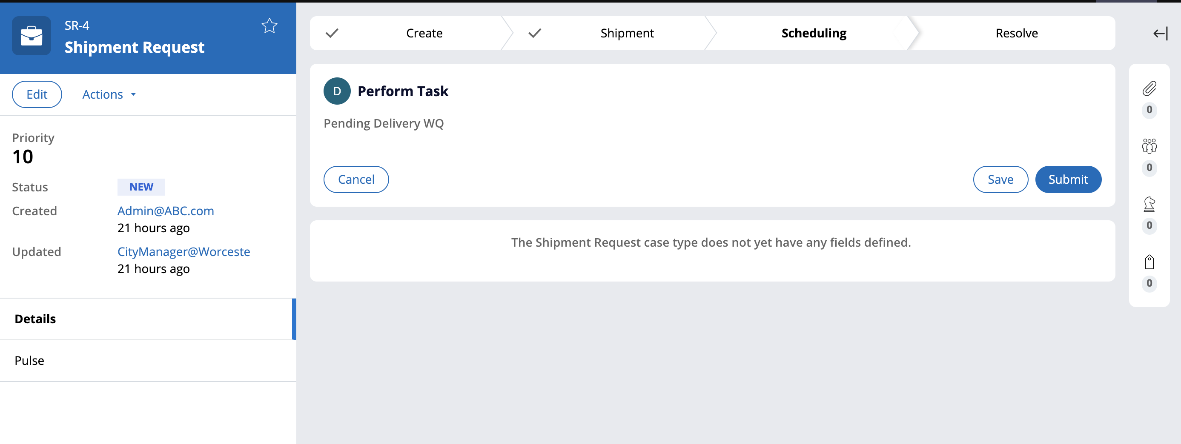

Once case is submitted case goes to resolved state and request feedback. Future scope to add feedback case creation than taking it from current assignment

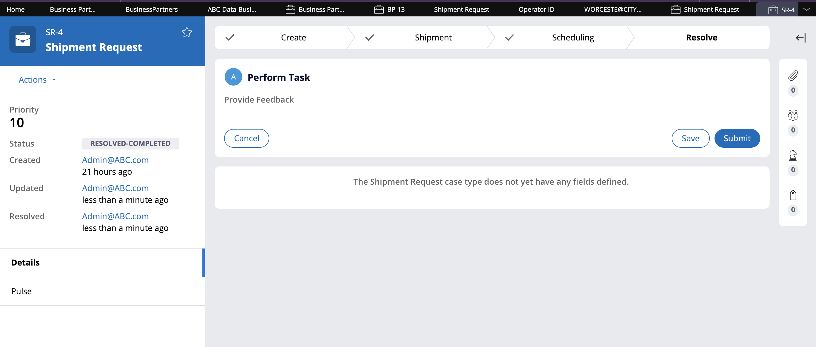

## Shipment Delivery Case

A shipment delivery case is created by Job Scheduler, based on the No of trucks.

**Case Life Cycle Diagram:**

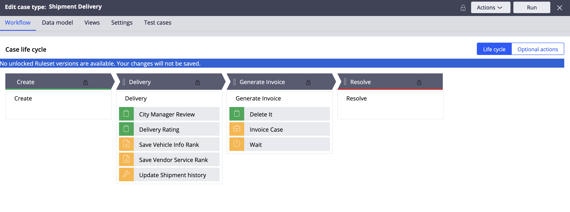

### Job Scheduler Logic (Implemented but not leveraged due to time constraint – Added Manual Creation Test Case)

If the “**DaliyShipmentLoad**” data type contains an instance for that specific date, shipment Delivery cases will be triggered according on the number of trucks computed based on the requests initiated for that day. For instance, the No of truck calculated as 5 trucks consolidating all the request. Job scheduler will run For Loop based on No of trucks property. In this case 5 cases are created and assigned to City Manager. An automated truck allocation is performed prior to case creation in the scheduler activity to the city manager ***(Priority Calculation)***. Trucks are decided from the vendors first in first out depending on the vendor's ranking (if both vendors have the same ranking, a random vendor will be chosen to determine the truck).

If there is case in which auto truck allocation could assign a truck vendor information because of no of truck ran out of allocation, City manager will be presented with Manual allocation (during the job scheduler execution, before case creation, the activity will update the case with Manual Flag), The logic to identify the truck based on the rounds will be reused for Manual allocation.

Login ID : [Admin@ABC.com](mailto:Admin@ABC.com) Password: rules

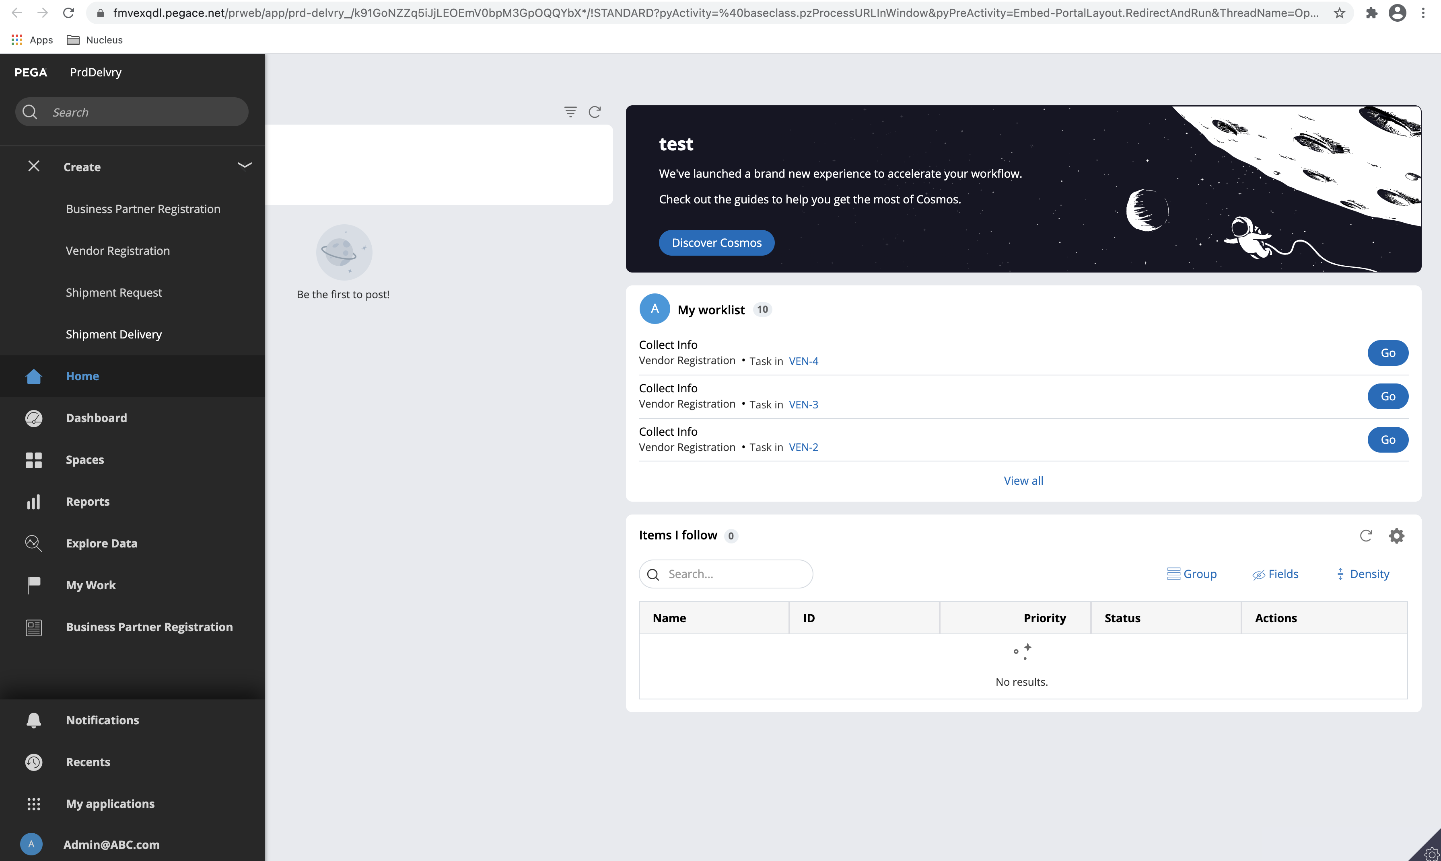

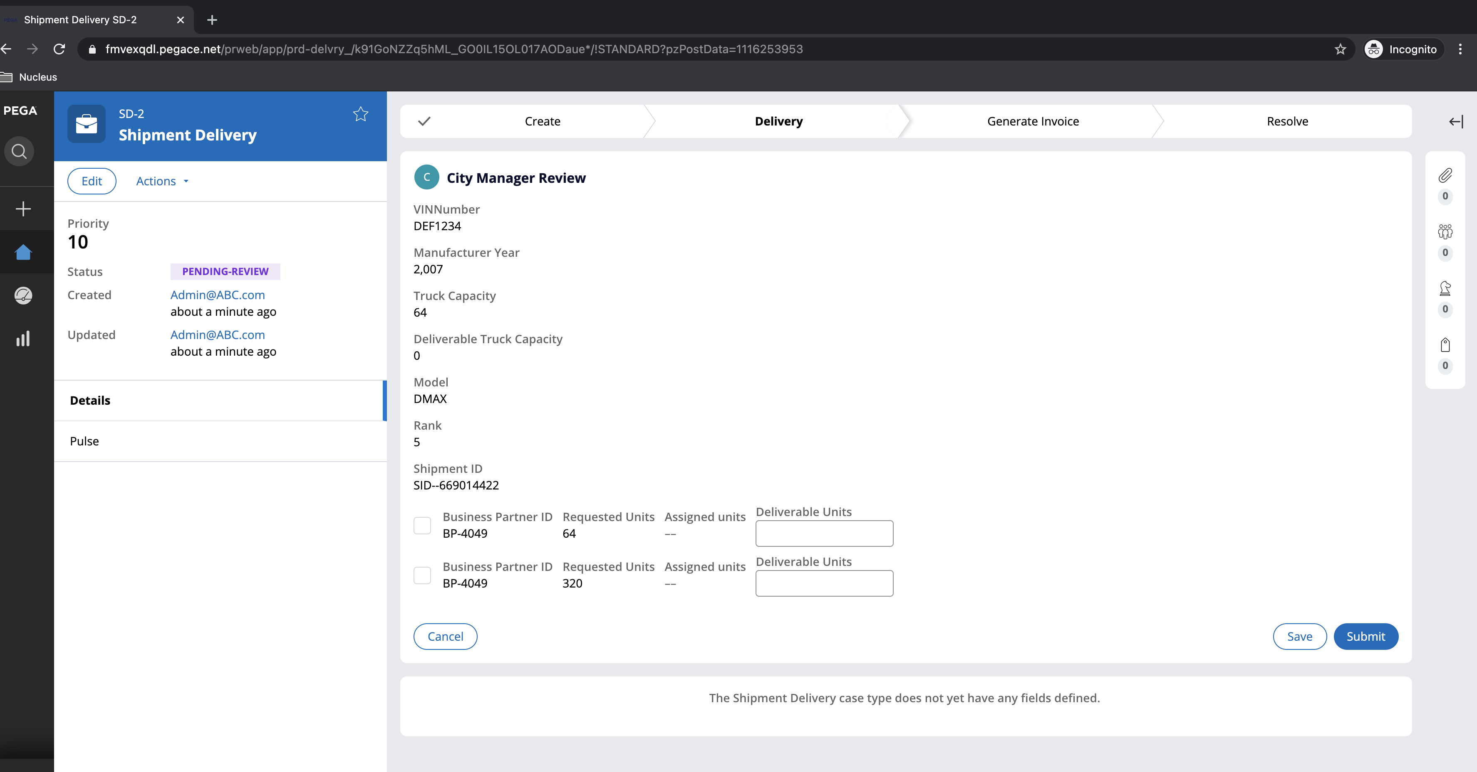

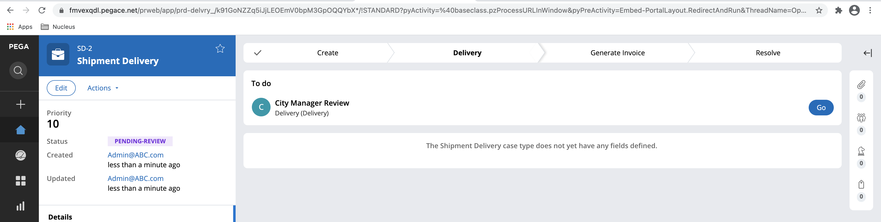

Login ID : Worceste@CityManager / Password : rules

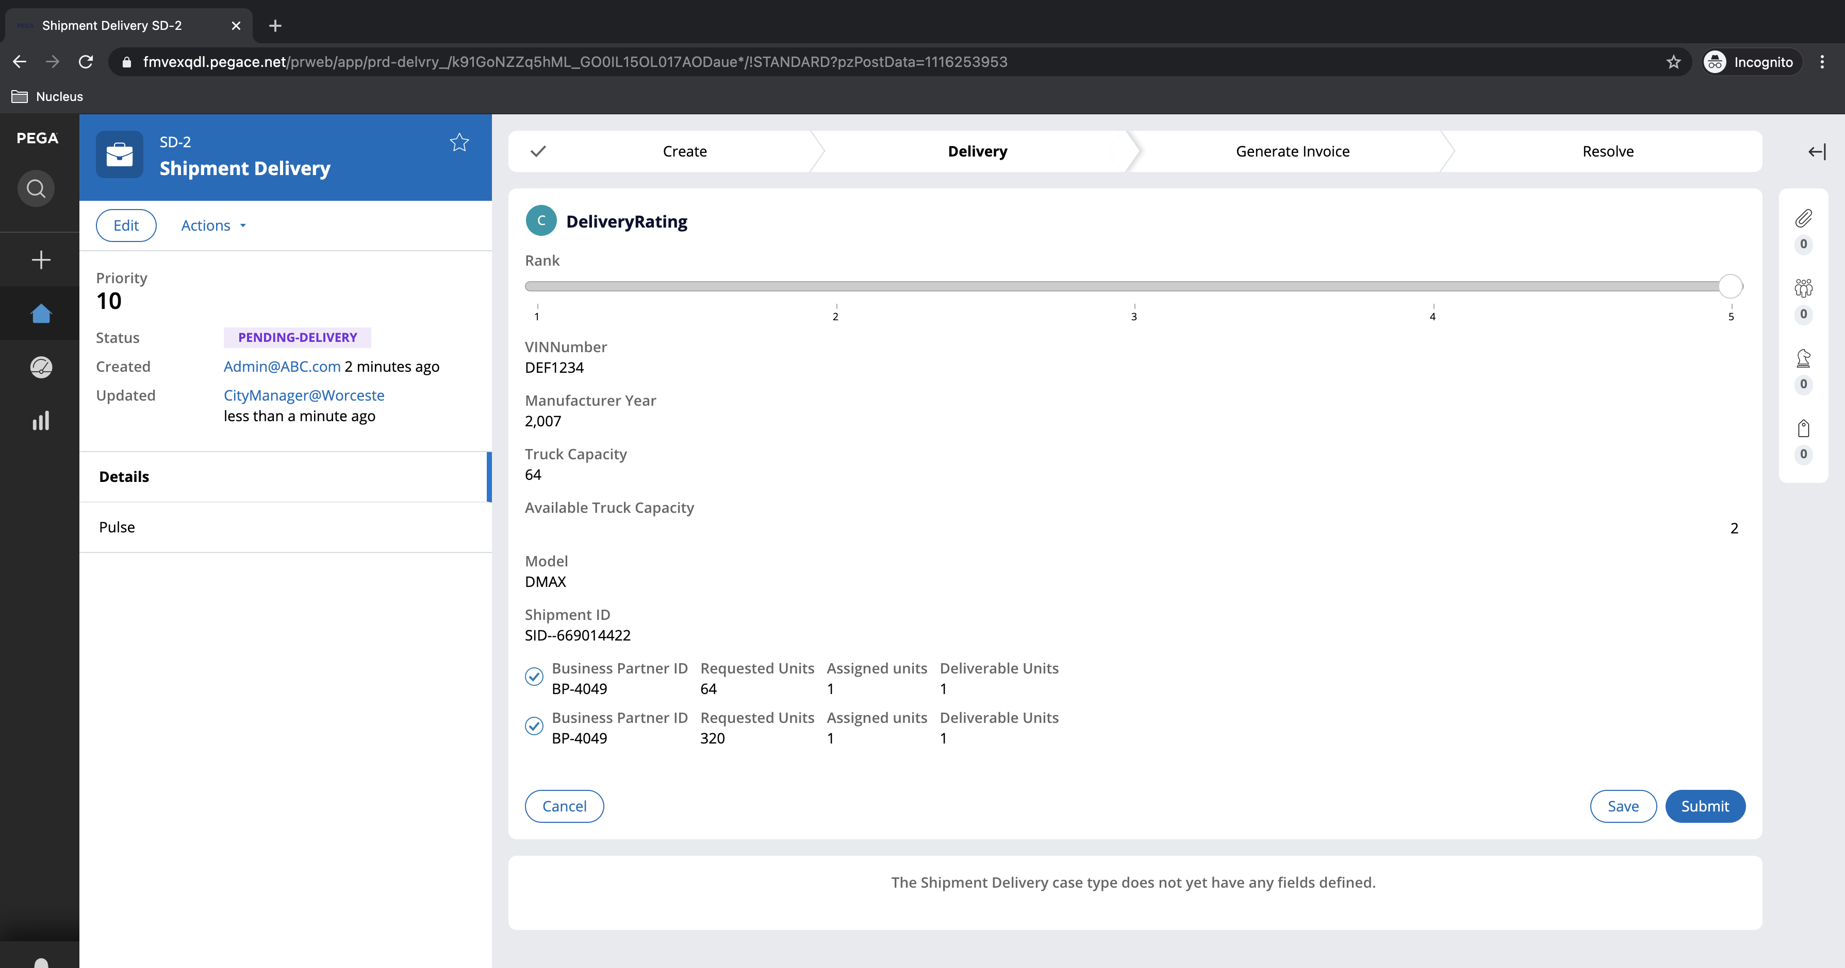

Once delivery request approved and delivery rating is done invoice case gets created

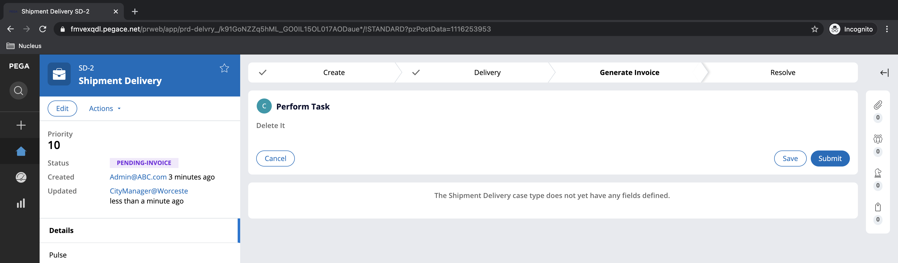

[Caveat: INVOICE PROCESS SET UP IS DONE HIGH LEVEL DUE TO TIME CONSTRAINT]

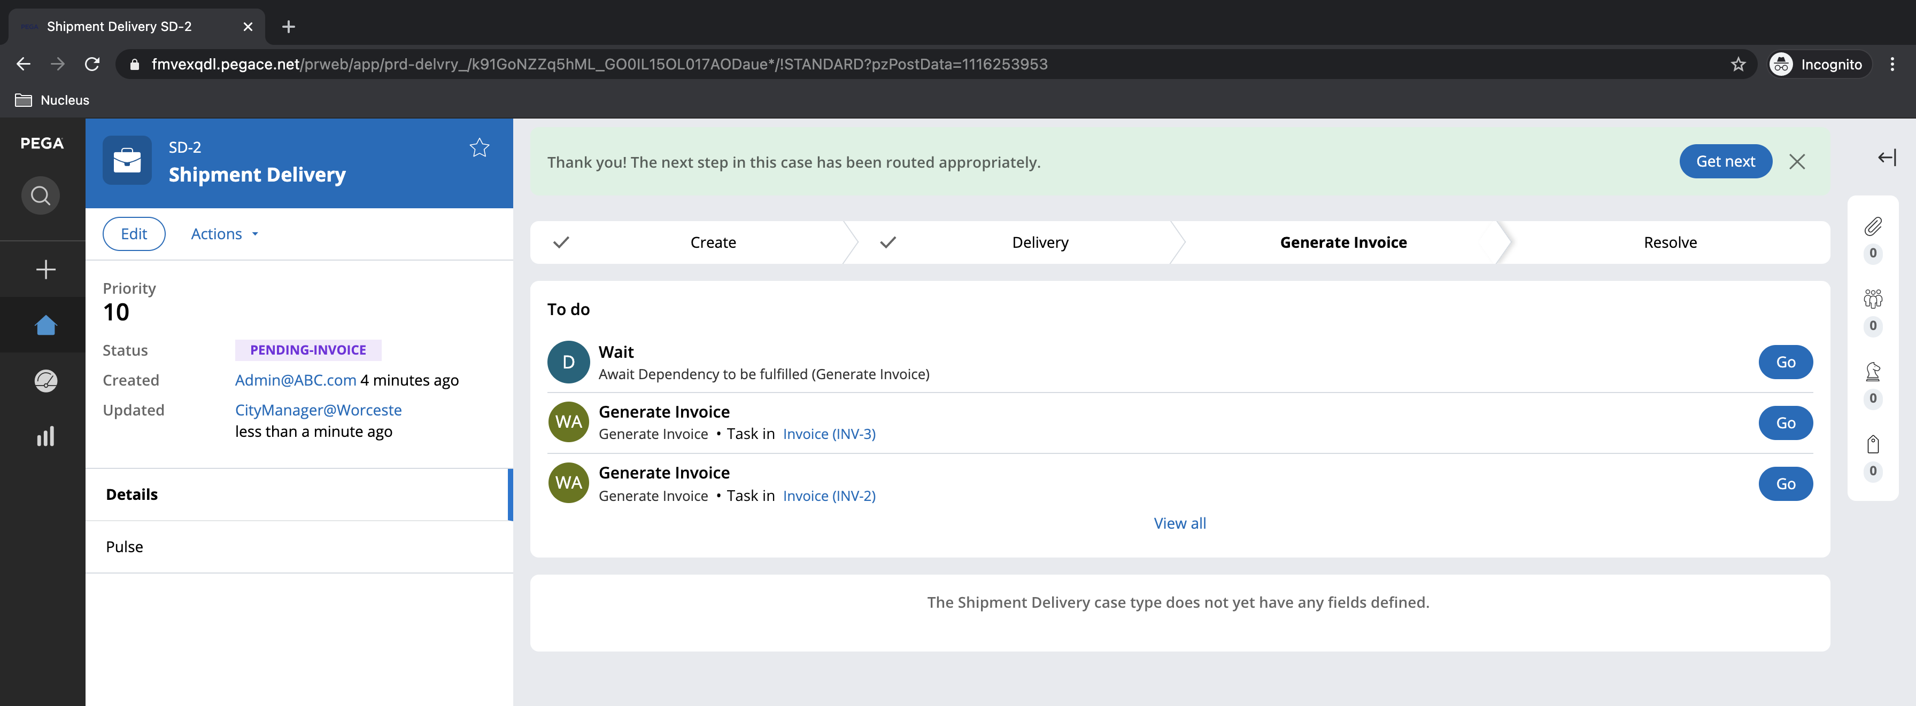

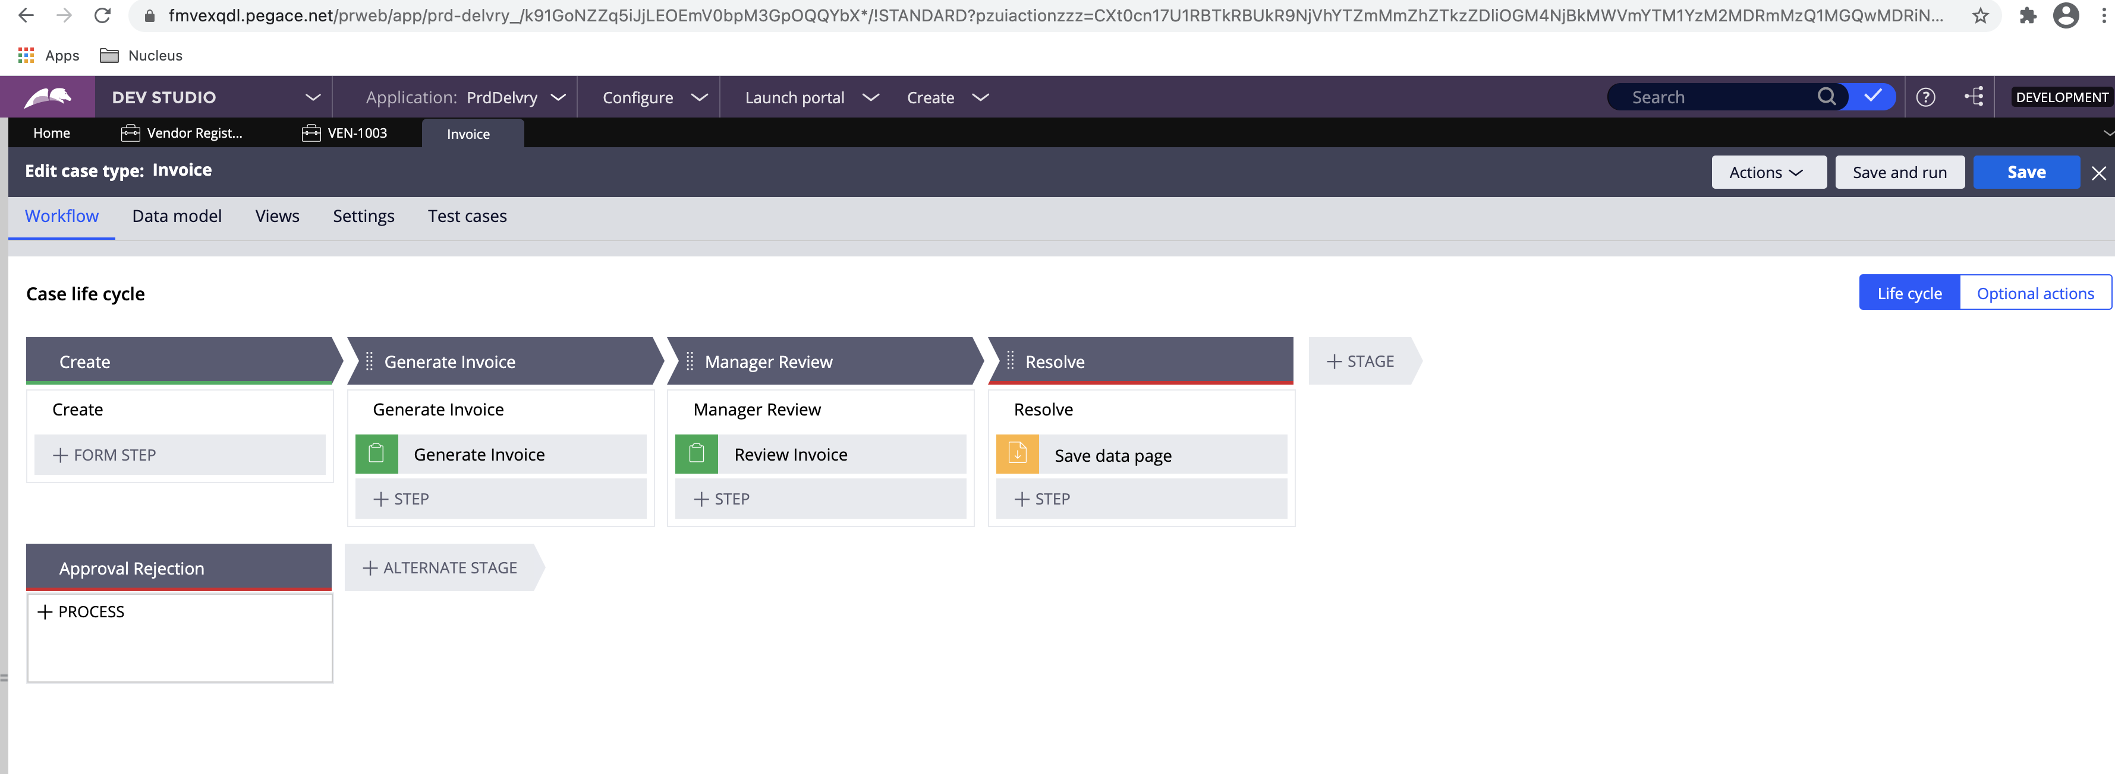

## Vendor Registration

Vendor registration process be similar to business partner registration though mash up channel set up to create vendor but [Admin@ABC.com](mailto:Admin@ABC.com) used to show the creation of vendor registration

**Case Lifecycle diagram:**

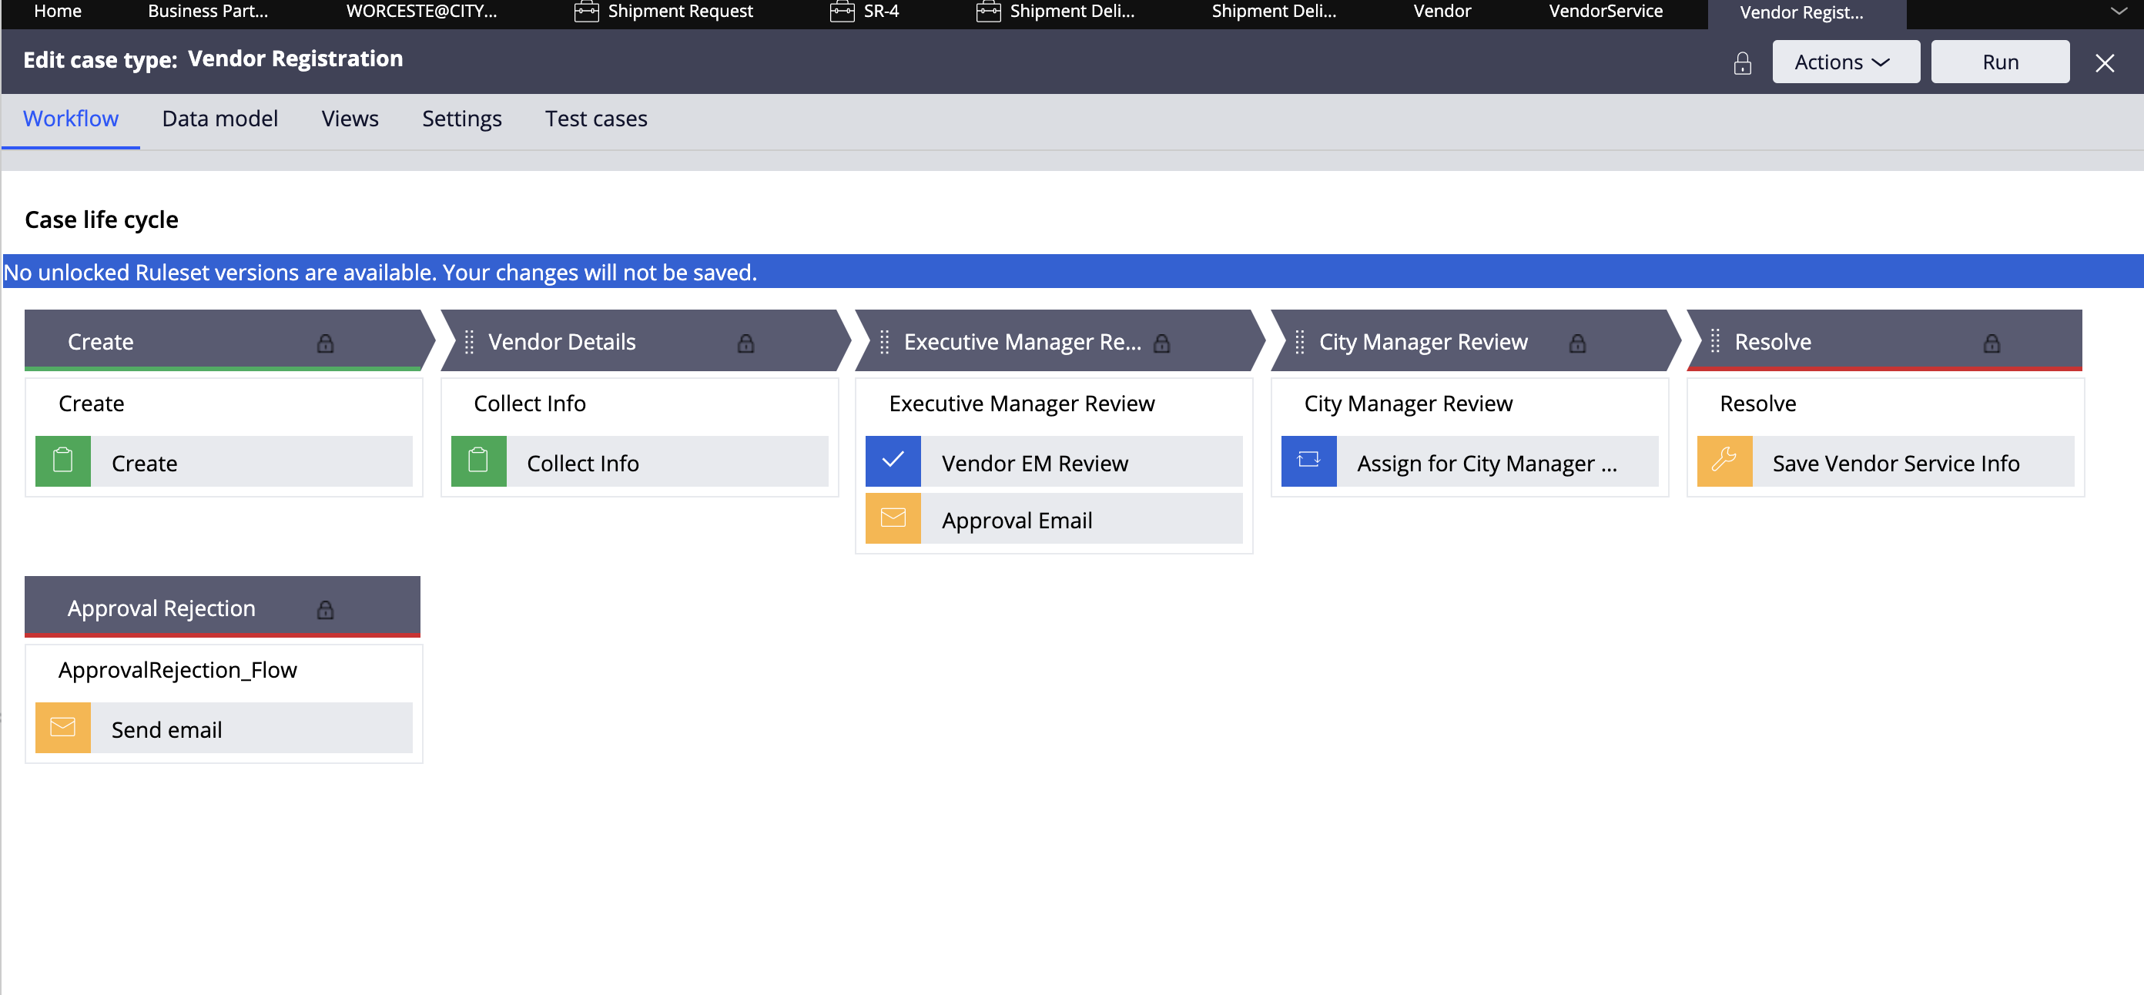

**Operator created :** [Admin@ABC.com](mailto:Admin@ABC.com)

**Password: rules**

Login as user and click on Vendor Registration case type

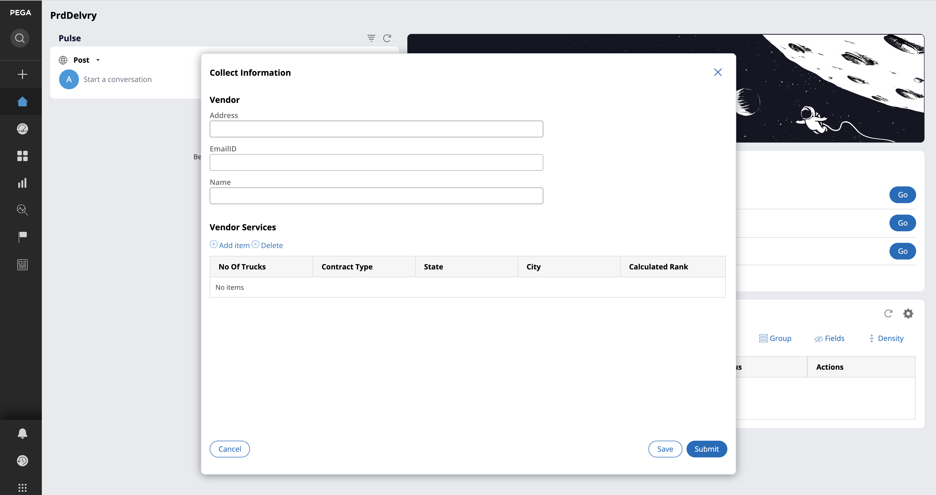

Case Created for filling vendor information and vendor service information:

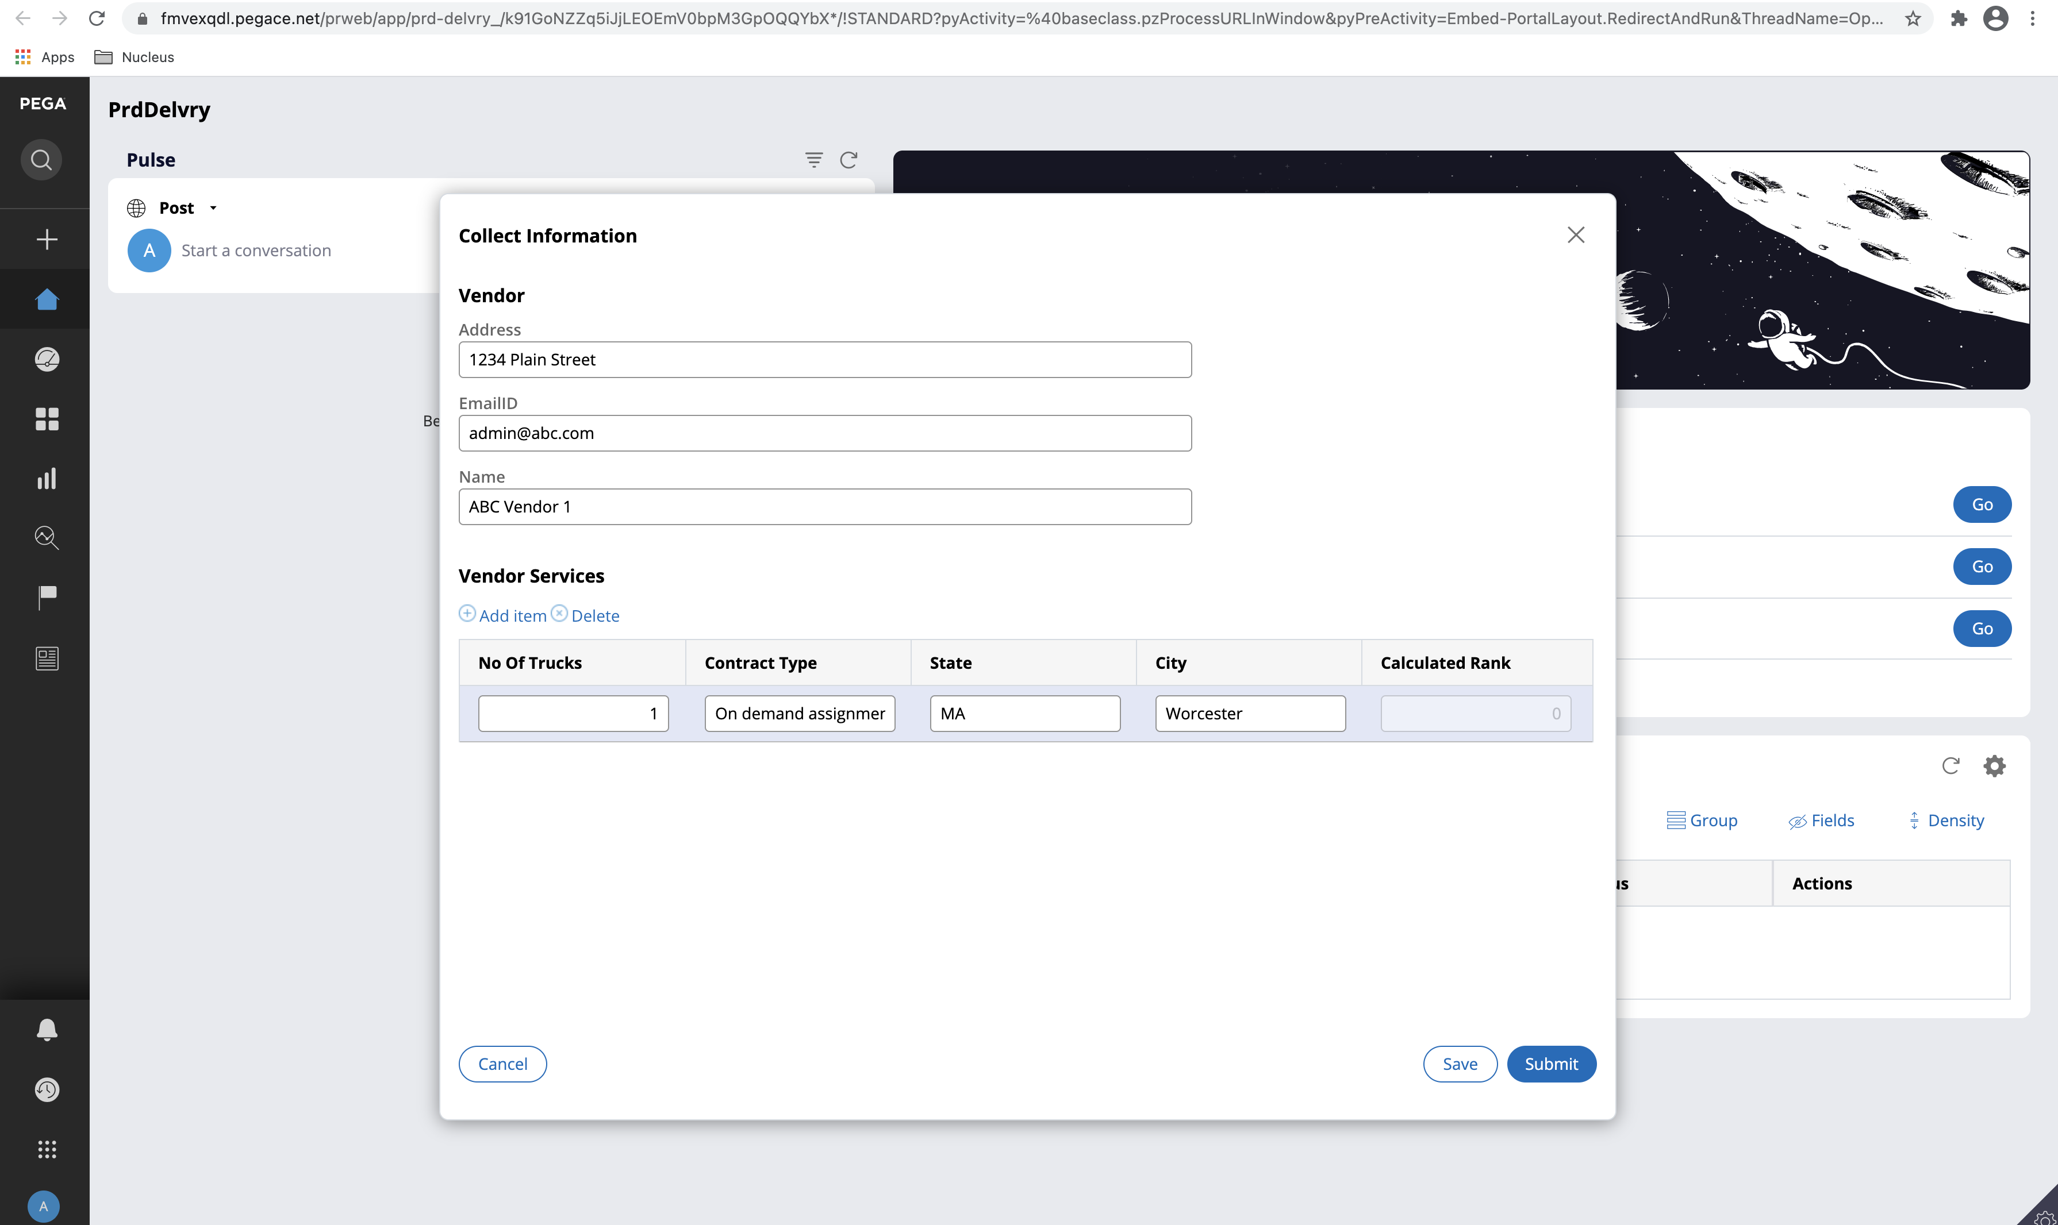

Case goes for Executive Manager Approval:

User Id : [User@Register.com](mailto:User@Register.com) Password: rules

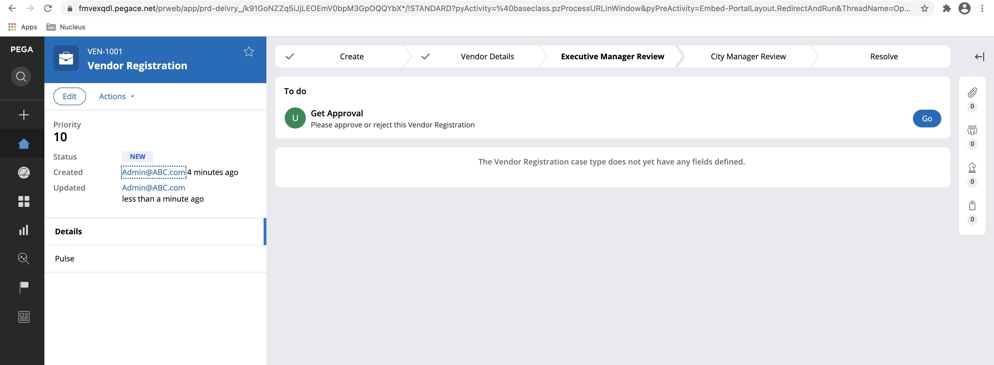

Executive Manager Approves the case:

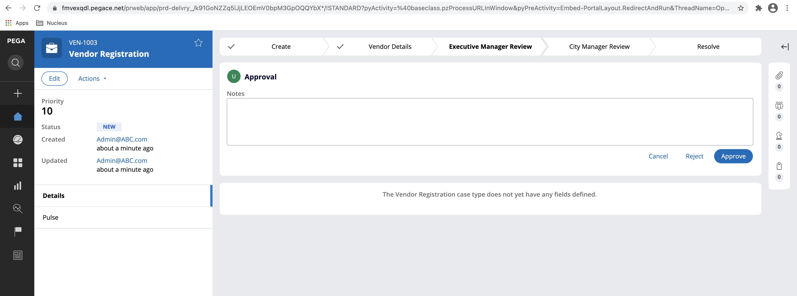

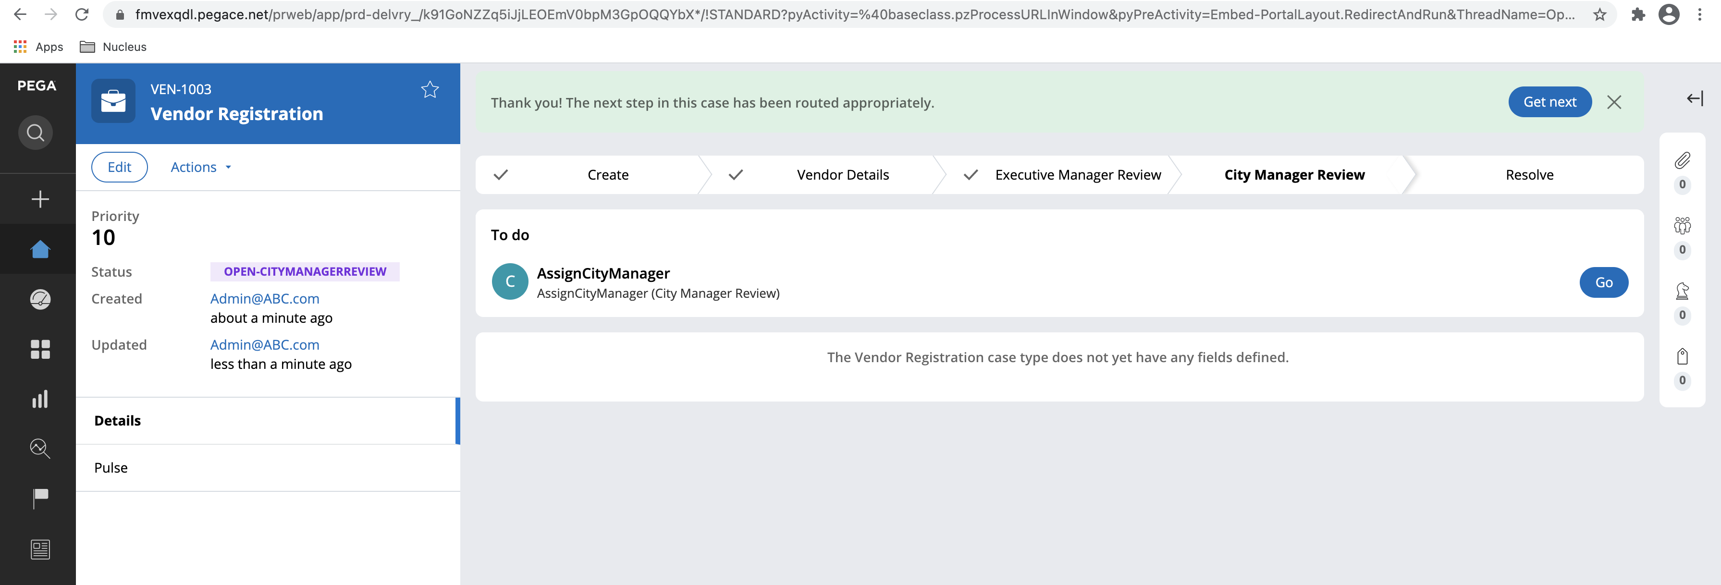

Case goes for City Manager Approval:

User Id : Worceste@CityManager Password: rules

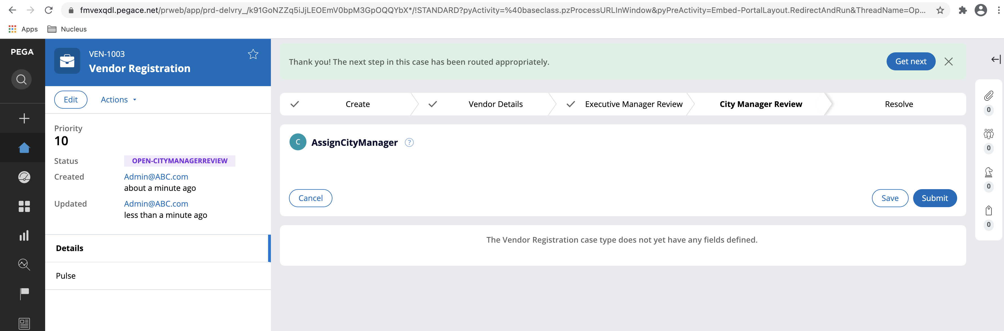

City Manager opens and approves the case:

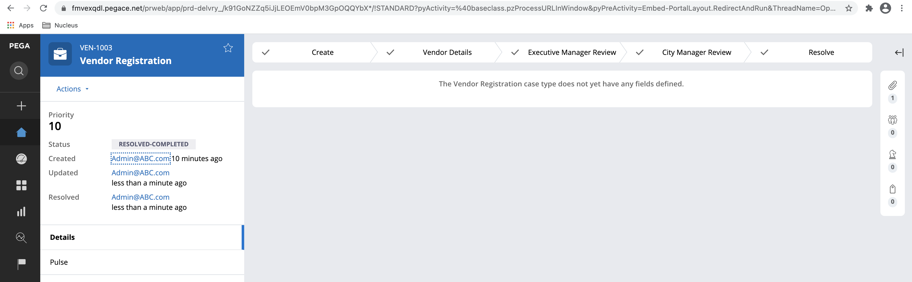

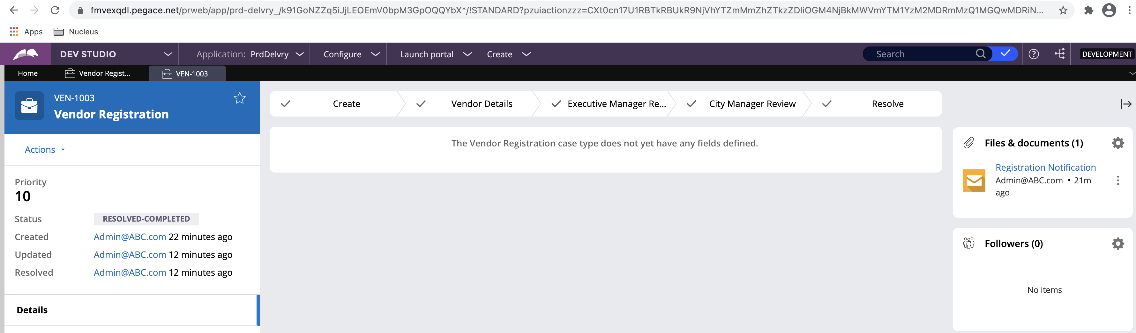

Vendor information and Vendor Service information gets saved into respective data types ABC-Data-Vendor & ABC-Data-VendorService

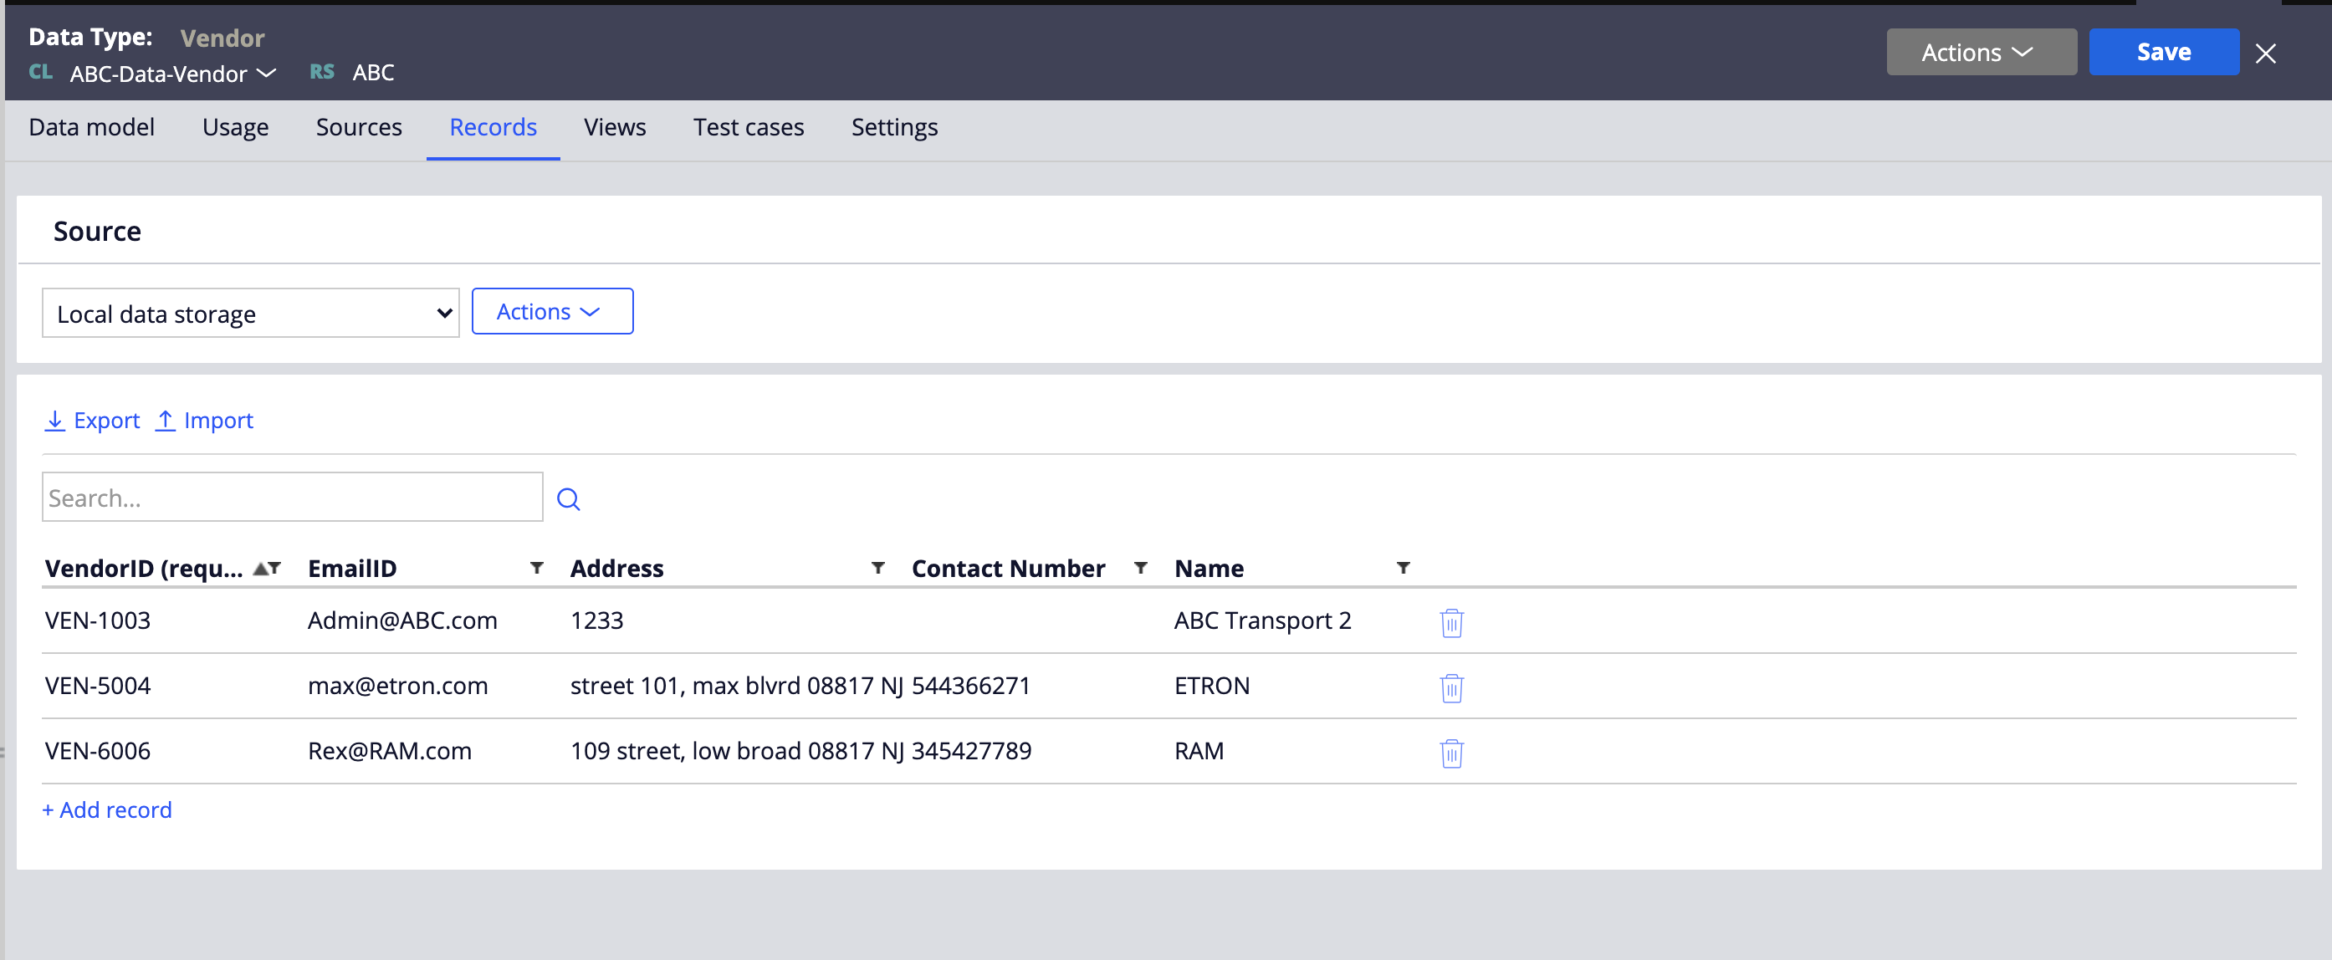

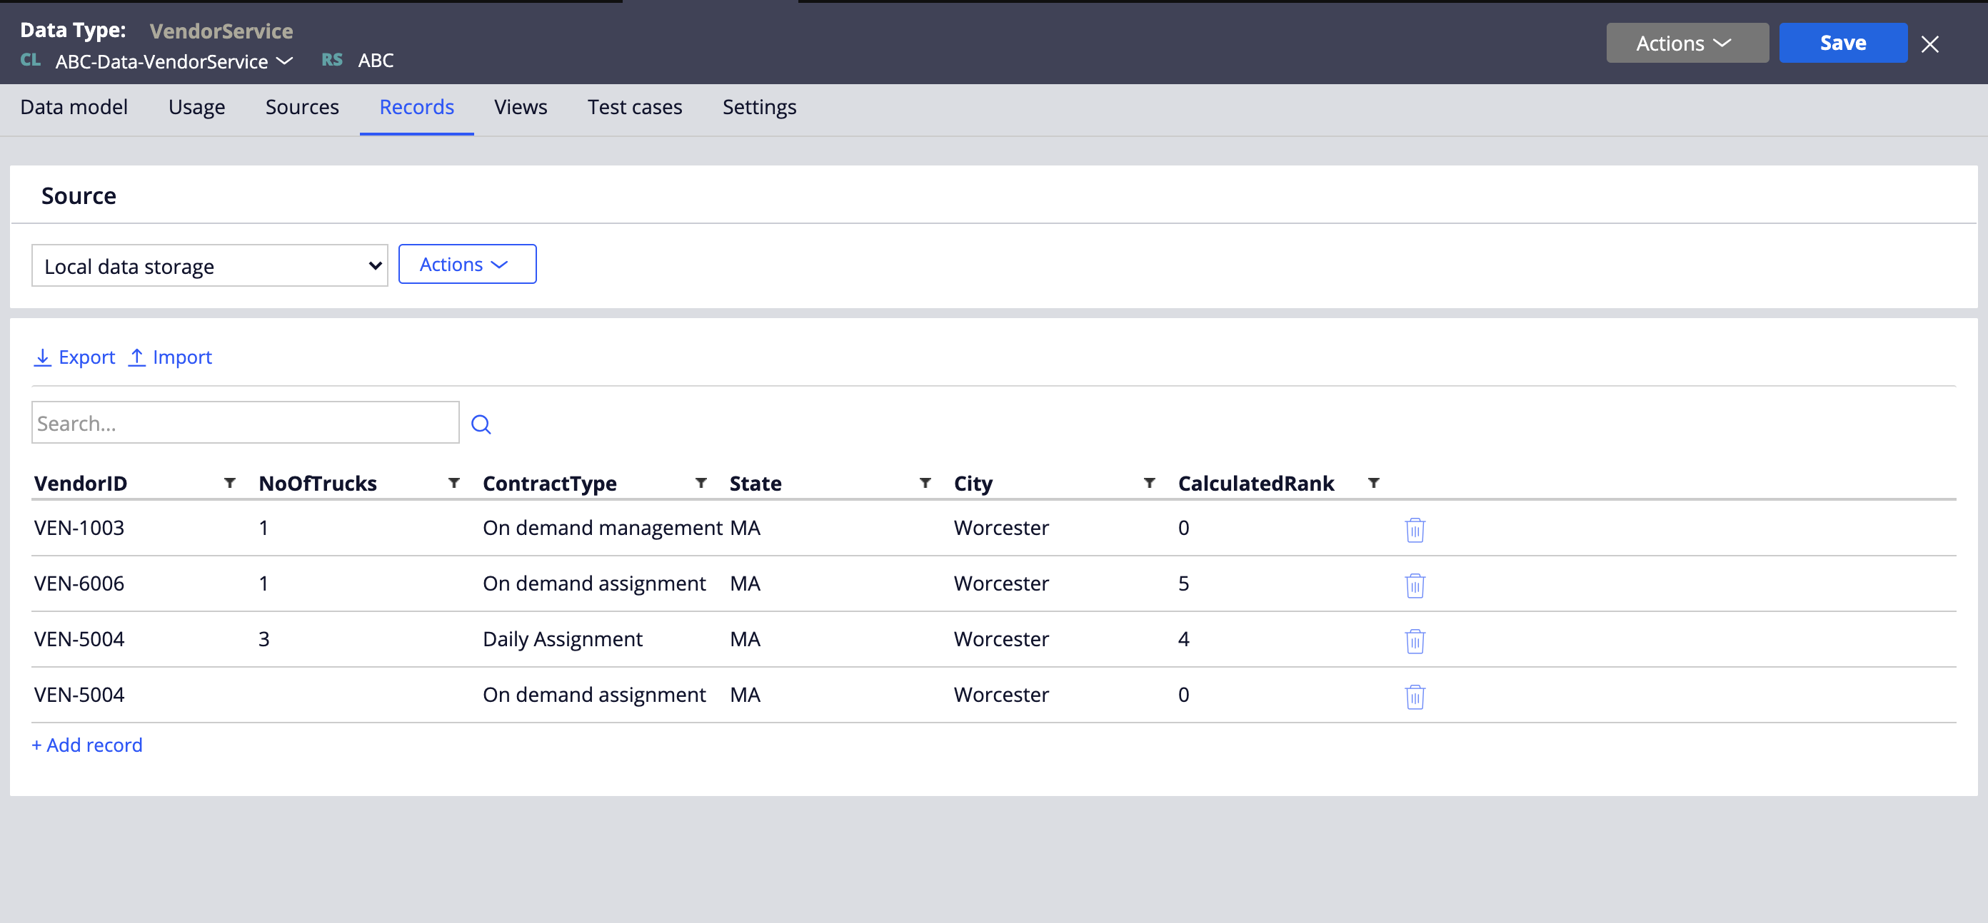

# Application Architecture:

## Application Preview:

The Application preview is given below:

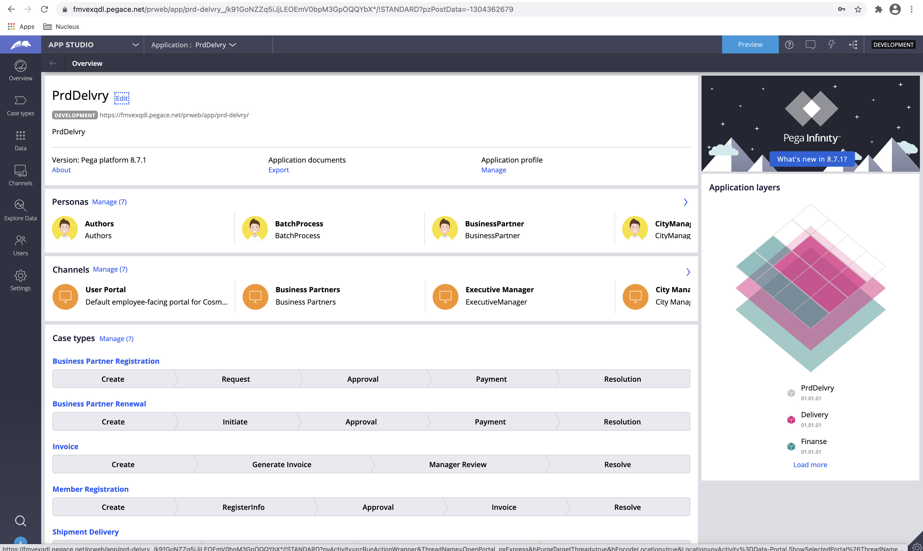

## Data Models:

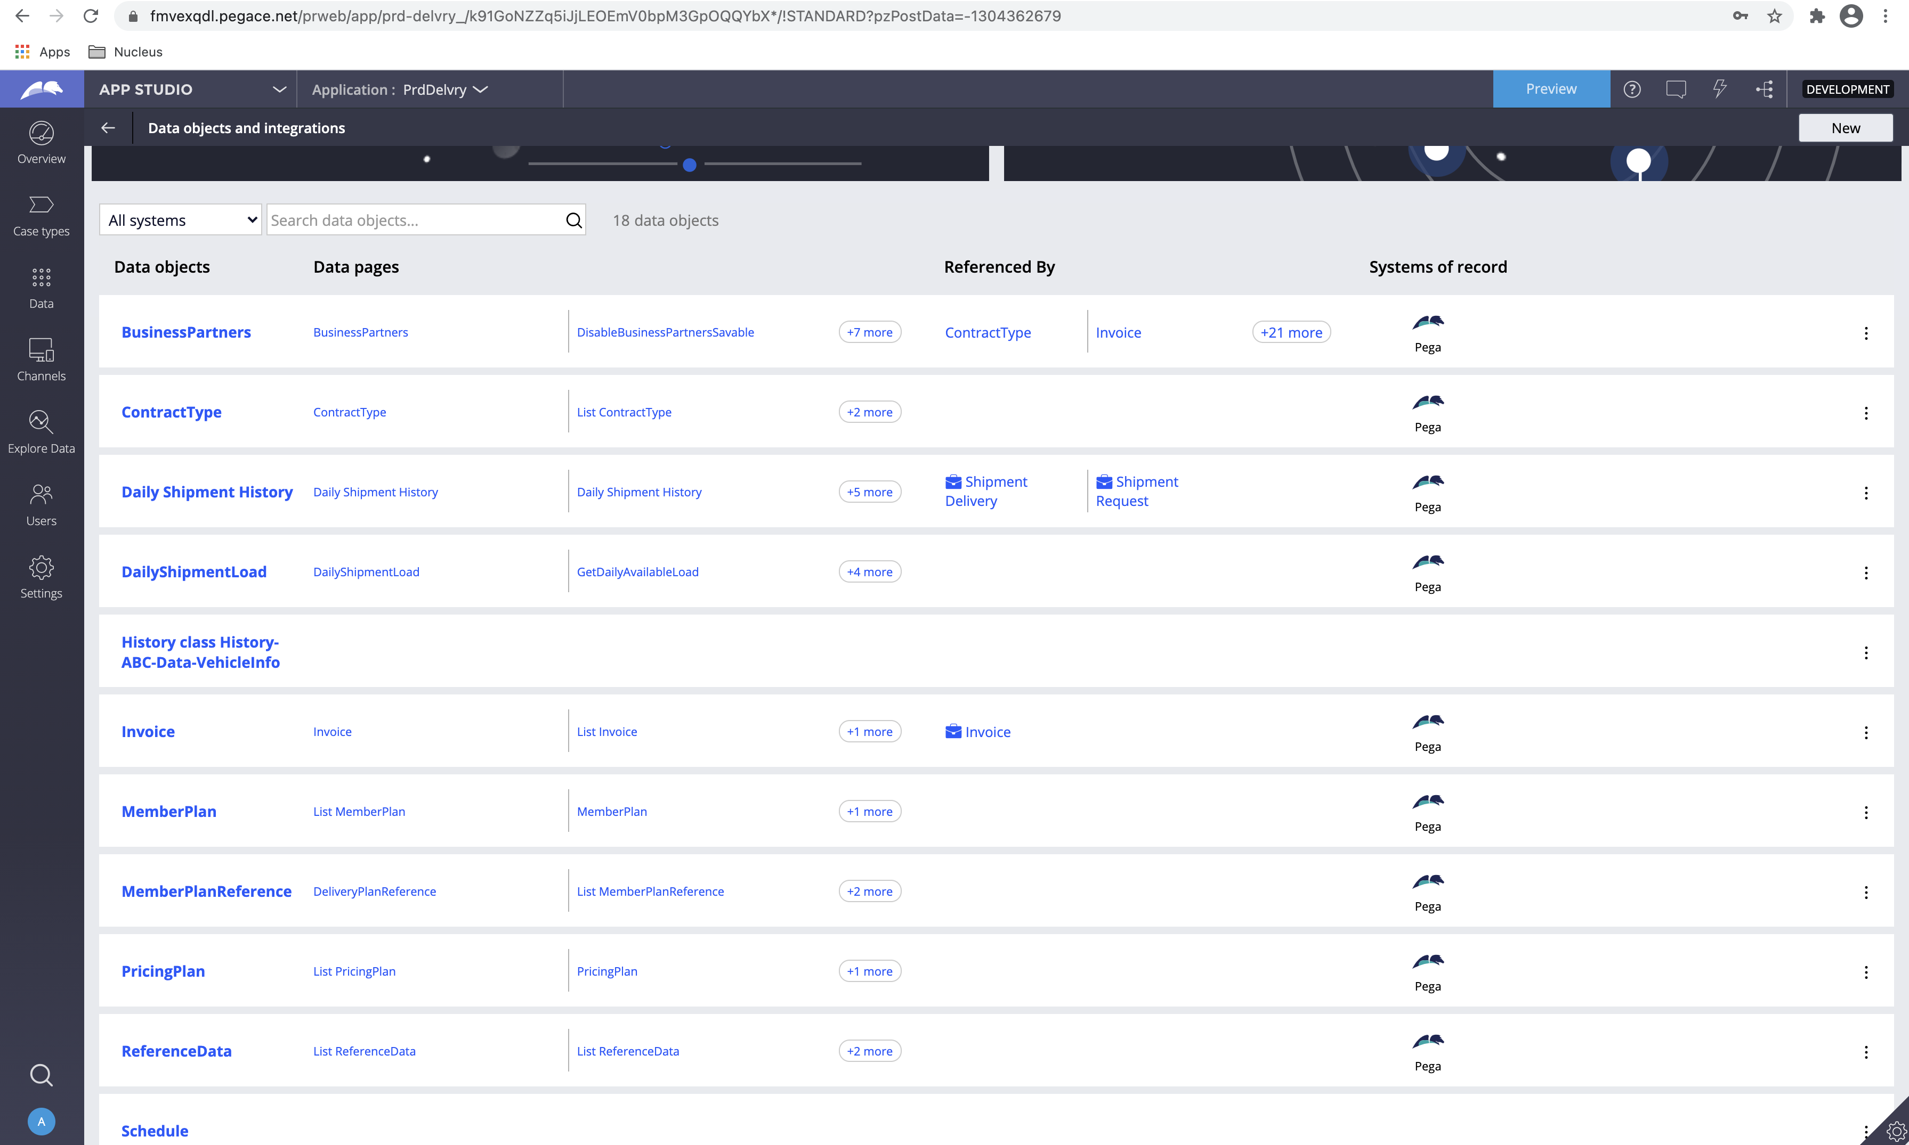

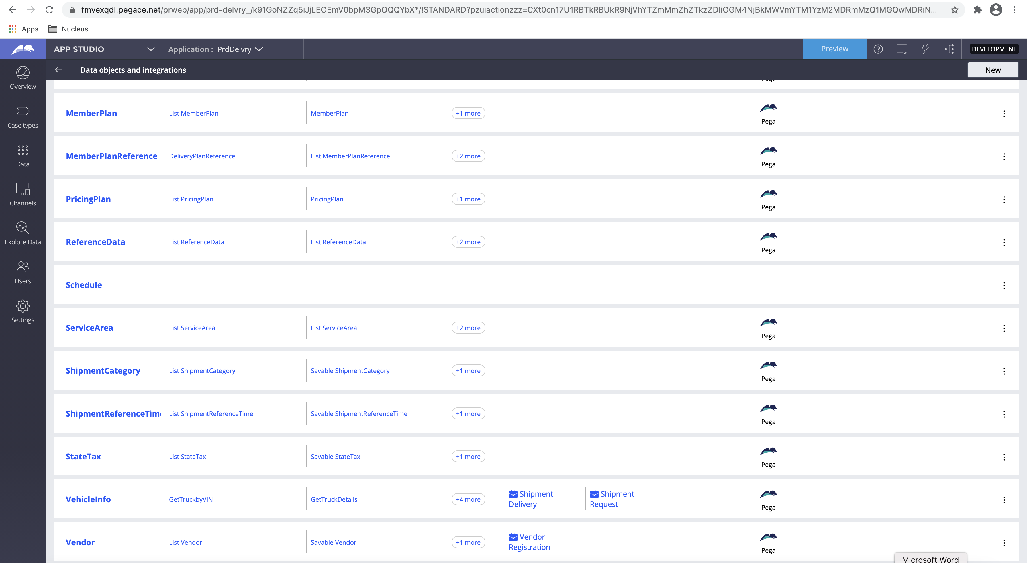

## Channels and Interfaces:

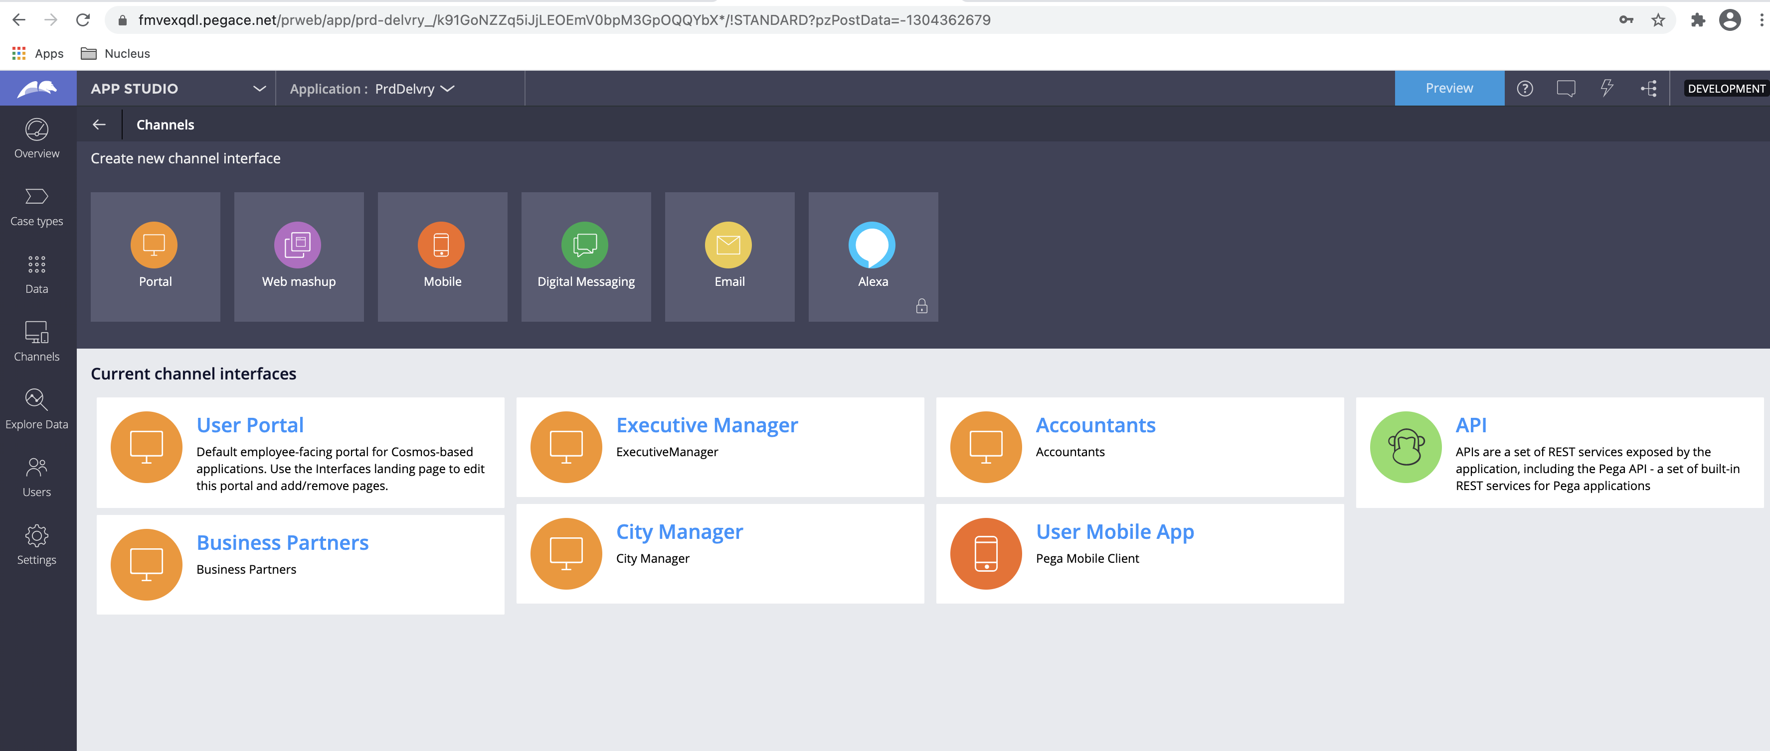

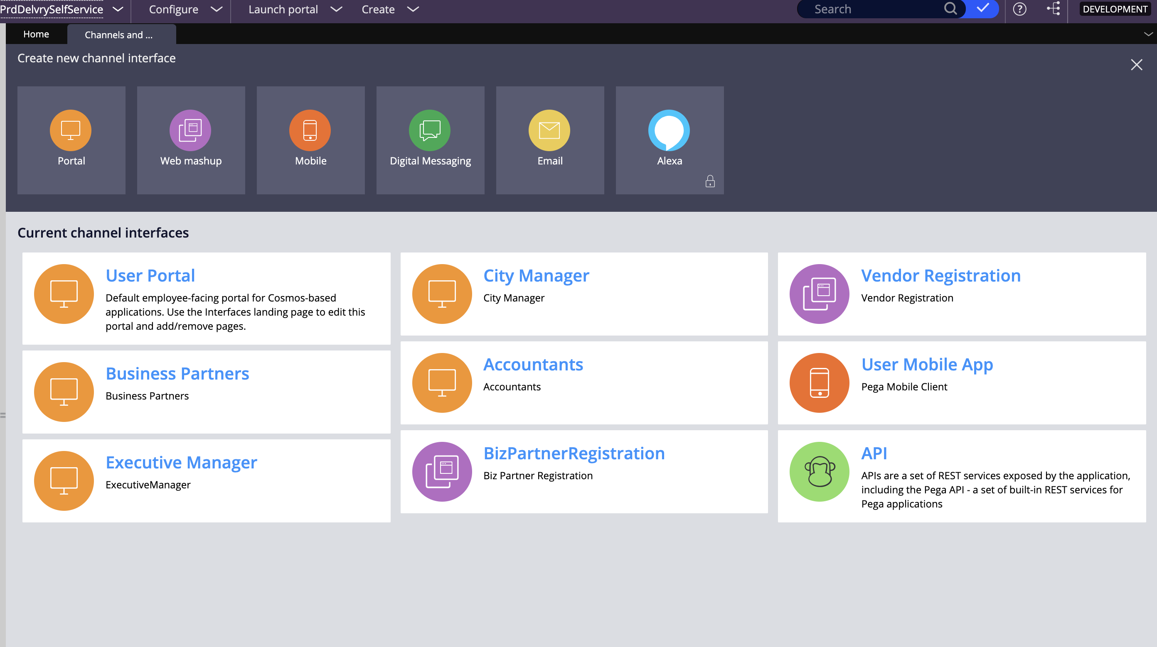

## Personas & Security:

Security is managed with different personas and their associated roles.

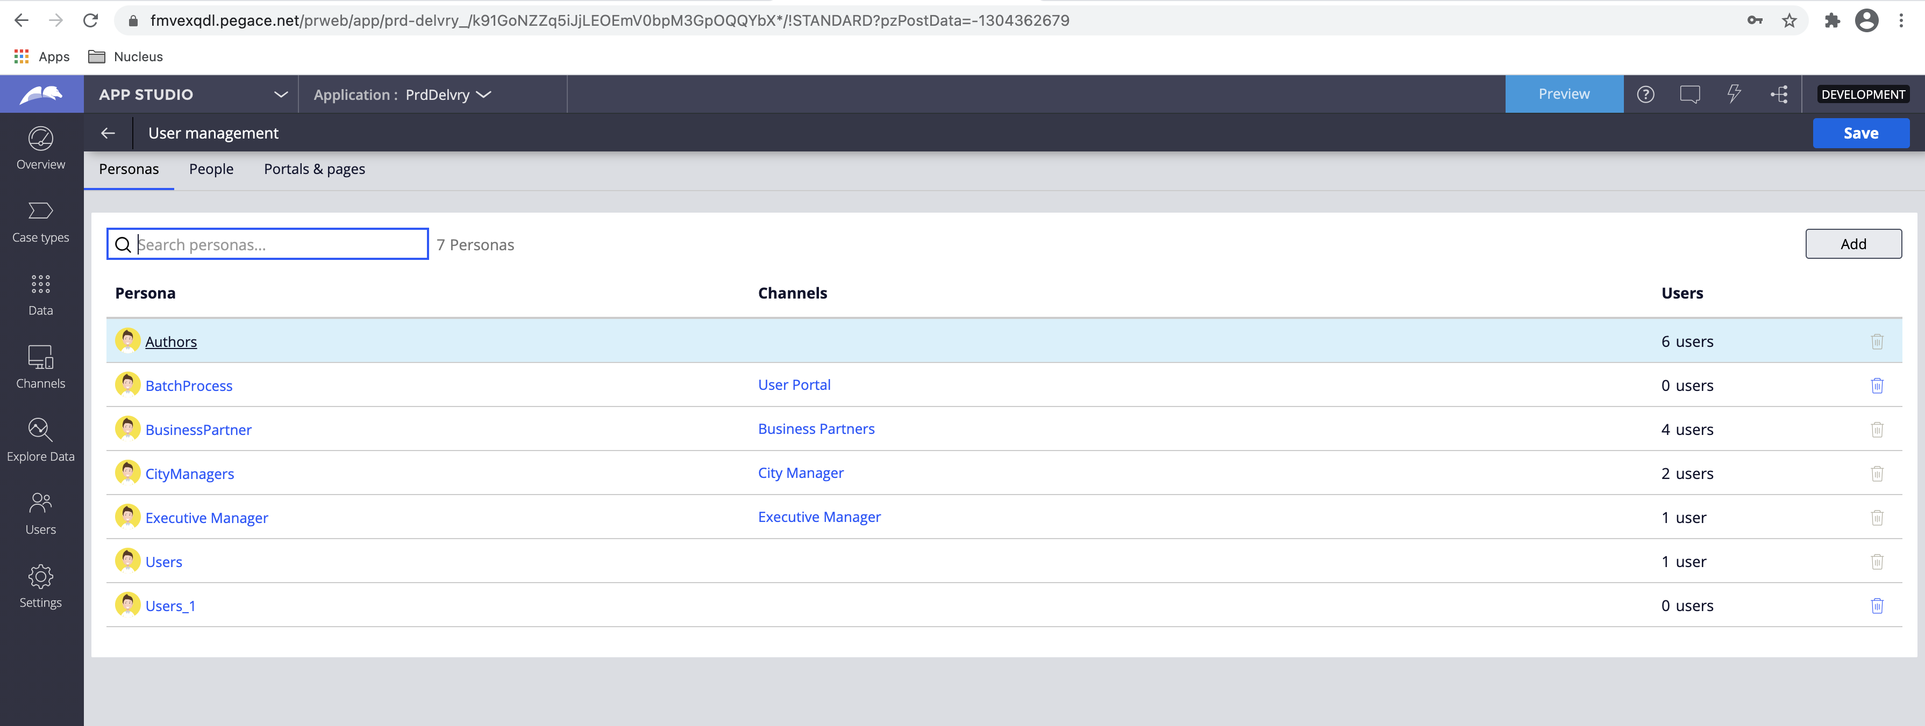

## Reports (Not Implemented due to time Constraint)

The reports are not implemented due to time constraint. If proper time was present, then those could be handled as follows:

### Executive Manager Profit Report

As mentioned in the requirement document profit should be defined as follows based on existing business operations. Amount received as part of ((business partner Registration/renewal+ shipment request) - Amount paid to the vendor for truck services utilized). This can be accomplished in a variety of ways.

**Recommended approach:** All the payment as per the application design involves invoicing. An invoice instance is created after city manager approval and after business partner registration/renewal. Also, an invoice case is created after delivery for a truck vendor. A report definition will be written on this invoice data object with function alias to calculate the profit after summation as per the invoice type.

**Alternate approach:** Run a period job using a job scheduler which keeps hitting the Invoice data type and calculates as per the above logic and updates a profit data type per day. This table will have present day profit. A report should be written on this table group by either week or month or year to get respective profit details. City also should be added a filter so that this report will be exposed to city manager to retrieve his city specific details only. ABAC would take care of restricting him from viewing another city details even if he changes city to a different city. In case of multiple cities for each city manager this report needs to be joined with skill class.

### Registration and Renewals Reports

As mentioned above both registrations and renewal are handled as part of single case type. Registration type would be a property which would define if the corresponding case is a new registration or renewal. A report needs to be written on this case type with dates as filter conditions. The same report definition should be scheduled to the executive manager. OOTB report scheduling should be used for the same. Please note two different reports can be scheduled for registration and renewals or one report grouped by registration type can be sent to just know the number of registrations. When the requirements are in detail one of the above can be used to achieve result.

### Products delivered per partner

As and when a shipment request case is created an entry is created or updated in the table (**ABC-Data-DailyShipmentLoad**). This entry would also hold details pertaining to the shipmentrequests raised for that day for that city. They are store in a embedded property ShipmentRequestDetails(Refer to Data model table). This embedded property has been indexed to class **Index-ShipmentRequest**. This will hold all the shipment requests along with business partner ID details. A report on this class filtered by business partner will be appropriate way to pull required results